BIOGRAPHICAL SKETCH

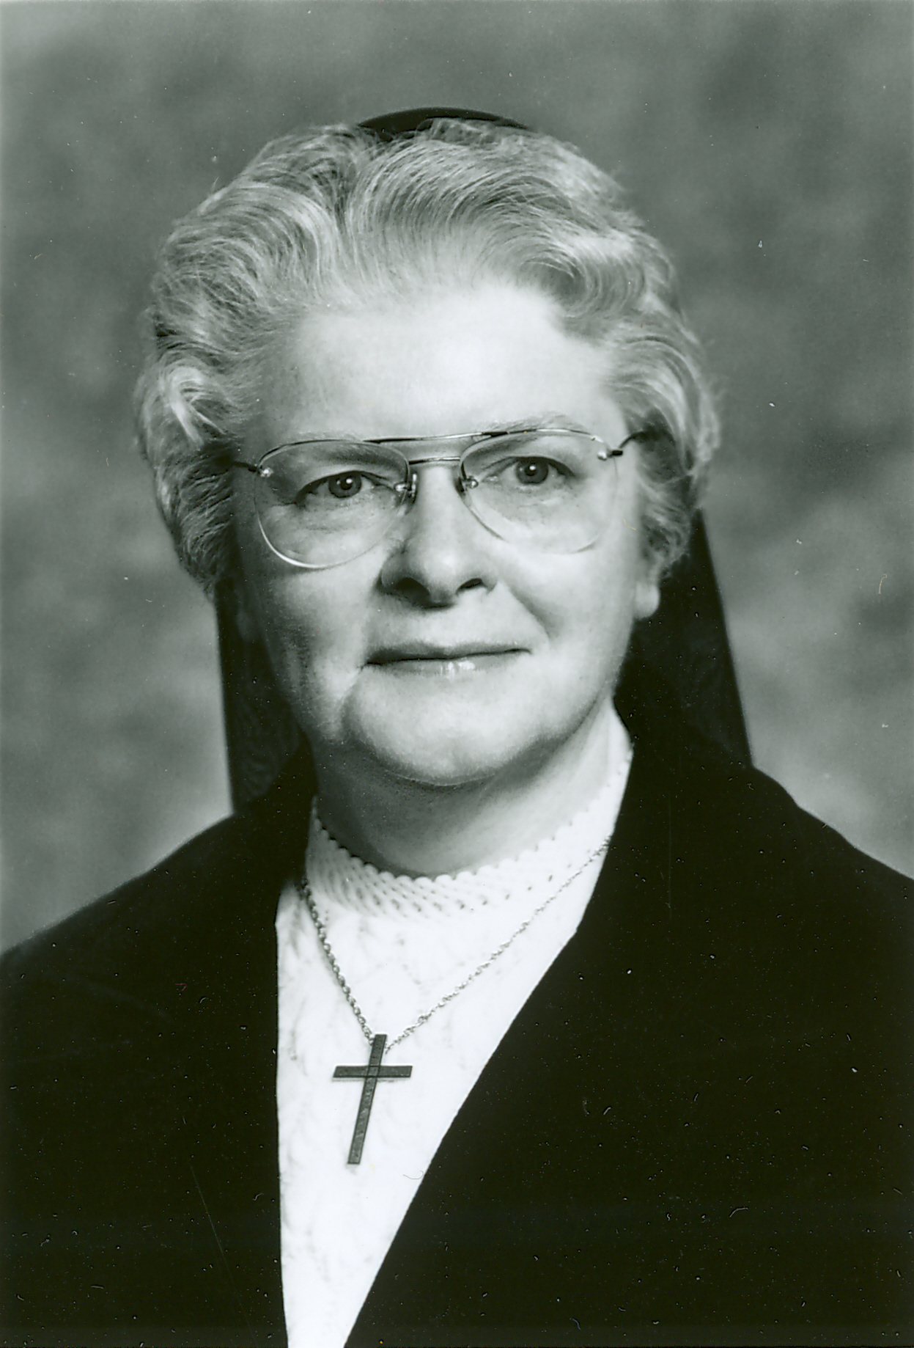

Sister Gertrude Champoux
(Sister St. Fernand-de-Jésus)

January 17, 1924 - May 24, 2014

“Be still and know that
I am God.”
(Psalm 46)

Sister Gertrude Champoux (S.S. Fernand-de-Jésus) completed her journey to her heavenly home on May 24, 2014. She was 90 years old and had enjoyed the local celebration of her 70 years of vows.

In the year 2006, in stillness and quiet, Sister Gertrude recorded the story of her experience of the unconditional love of God in every instance of her life–even before she was born, she stated.

The following is her autobiography written in the winter of her long, fruitful life of love and beauty.

Grandfather Arthur Champoux was from the 6th generation of the Champoux dit St-Père. He was born in Arthabaska, P. Q. in 1861.

Grandmother Athenaise Morin was born in Ste-Louise, Lislet, P.Q. in 1859. At the age of 13, she came to Biddeford, Maine to work in the cotton mills until her marriage in 1885. She instilled a love of history in her grandchildren by relating many interesting anecdotes concerning the early beginning of the city of Biddeford and of St. Joseph Parish.

My maternal grandparents were Grandfather Cleophas Roy who was born at St. Bernard Dorchester, P.Q. His wife was Cédulie Paquette who was born in St. Sylvestre, P.Q. Both my paternal and maternal grandparents immigrated to Biddeford, Maine with their children in the early 20th century.
My father, Wilfrid, was born in 1891 in Arthabaska, P.Q. He was a laborer, working in a bakery and in cotton mills. In 1921, he married Georgiana Roy, originally from St. Narcisse de Beaurivage, Lotbinière, P.Q. The ceremony, a double wedding, consisting of my parents and my mother’s sister, Anna, and her husband, George Nadeau, was held in their parish church in Biddeford, Maine.

My mother was a school teacher in her hometown in Canada. After her wedding she became a full-time housewife working out of the home only in times of dire necessity. My maternal grandparents came to live with us when my parents built their home three years after their wedding. They remained with us until their deaths.

My paternal grandparents lived next door with three celibate daughters. Pepère died at 78 years and Memère at 99 years.

We were a family of five children. Rita, yours truly, Florian, Fernand (who died of leukemia at 13 years old) and Leo who was 8 years old when I entered the convent.

I was born on January 17, 1924. I was baptized Mary Gertrude Jeanne d’Arc on January 18, 1924. I was nurtured in a healthy, happy and Christian atmosphere. The presence of my grandparents probably enhanced the priority of prayer in our home. Although far from being wealthy, my parents raised their family in relative comfort but without luxury.

At the age of five, I almost died of pneumonia. A few months later, I attended St. Joseph School and was taught by the Good Shepherd Sisters. In the spring of 1930, I made my First Holy Communion. I was considered to be a good student, but I preferred home activities to studies. I was docile in school, but my fiery temperament was too often displayed at home. My poor mother used to say: “Gertrude n’a pas les cheveux rouges pour rien”. I tried to curb my temper, but often met with failure.

At the age of eight, I received the Sacrament of Confirmation. This great privilege is more vivid in my memory than my first encounter with Jesus in Holy Communion. The preparations to receive the Spirit were thorough and I realized that this sacrament was very special.

Elementary school years continued smoothly as well as life at home. I was considered reliable and responsible. I was often asked to baby-sit, a service that spread and continued until I entered the convent at the age of 18.

My high school years became somewhat less quiet with the insecurities of the adolescent trying to find herself in the world. I enjoyed good times but had few close friends. I was more comfortable in the company of intimate friends–either male or female. I worked part-time at department stores throughout my high school years.

Through my school years, many remarkable S.C.I.M. teachers made an impact on my life. In June, 1942, I graduated from high school with seven other companions. Two of them entered the Novitiate with me. They are Sister Theresa Bouthot and the late Sister Rita Grondin.

I cannot say at what particular moment in my life I decided to consecrate myself to God. It seems as though I have always had that attraction. The home atmosphere must have contributed to encourage that desire. My mother’s hope for a religious in the family was directed to my sister, Rita, who had been endowed with apparently better qualities for this calling than me. Mother had offered her first-born to Christ shortly after Rita’s birth., since her own desire for religious life had been deterred by the wise counsel of the Sisters at Ste-Marie de Beauce where she completed her studies. Little did she suspect that God was after her less-disciplined child!

Although my good and understanding parents would have welcomed confidences, it was not in our nature to be open with them. And so, life went on with my aspirations.

On August 25, 1941, exactly a year prior to expected admission to the novitiate, I told my mother of my intent. This day happened to be her birthday. Was this announcement a birthday present for her or a joy that manifested itself in a double loss since my younger brother, Fernand, had already been diagnosed with acute leukemia that took his life less than six weeks later?

I had no reason to expect resistance from my kind, Christian father. But my false sense of justice made me feel very guilty to leave when, for the first time in my life, I could repay him somewhat for some of the many things he had given to me over the years. So I asked my mother to inform him of my intentions. Never again did I bring up the subject of religious life until the following spring.

My senior year of high school was spent through periods of sorrow and periods of joy. Daily Mass and certain exercises of prayer suggested by my teacher, Sister Mary Anne Therrien, S.C.I.M., who diligently directed me without pressure toward the novitiate, probably kept me in balance with the social life I wished to live to the fullest. Fortunately, I had good friends and although I was allowed to taste of the things of the world and enjoyed them, I never regretted these activities.

With the coming of spring, the immediate preparations for entering the convent had to be made. Father Zenon Charette, a parish priest and a good friend of the family, discretely familiarized my father with religious life. Dad’s contacts with Sisters were remote even though he always respected them.

August 25, 1942 was admission day to the Novitiate with six companions–all of whom were either classmates or acquaintances. Although meaningful to me, these two years passed by very unnoticed to many except perhaps Sister St. Misaël, the convent seamstress who took a special liking for me–certainly not for my efficiency in sewing! Only in heaven will I know and fully appreciate the extent of her unselfish and genuine love for me.

August 13, 1943 was Reception Day at the convent chapel when I donned the religious habit and was given the name of Sister Fernand of Jesus. This name I kept until 1968 when we returned to our civil names.

August 15, 1944 was my Profession Day. The ceremony was held at St. Joseph Church. With what fervor I made the promises that somehow I knew would be fully understood only later as far as love/pain price is concerned. God accepted my offering and to this day, this acceptance has been a source of my love for Him who proved His faith and His trust in me.

In 1944-45, I spent a year at our Mother House in Quebec City and attended college. In 1945 I was assigned to our convent in Van Buren, Maine, and began my teaching career which I thought would be my life-long endeavor. I enjoyed this apostolate very much at the time but soon learned it was not to last. In September, 1947, I was asked by the Provincial Administration to begin studies for a nursing career. I began my three-year course at Mercy Hospital School of Nursing in Portland, Maine. Upon graduation, I was assigned to St. André Home and Hospital where I remained for a period of 25 years, ministering to some married mothers of the area, but mostly to the unwed mothers and their babies. The long and unscheduled hours were demanding but they brought physical, psychological and hopefully spiritual comfort to the isolated mother throughout her pre-natal, labor, delivery and post-partum periods. The offspring, a delicate flower, also deserved much attention which did not stop at sunset. All these hours contributed, I hope, helped for the redemption of souls.

My nursing career would not be complete without ministering to the Sisters of my Community. This I have done over the years, but especially in Bay View, Saco (1963-1967). These years were gratified by many instances of edification.

After a bout of health problems and being forced to limit my activities, I decided, with the encouragement of my superiors, to apply my nursing knowledge in the field of Podiatry, a service limited to the Sisters and very much in demand, if I may judge by the number of Sisters who required my services.

Another field in which my nursing background was put to use was in the Medical Records Department. At St. André Home and Hospital where I reviewed and categorized thousands of medical files according to the State Requirements. I was also asked by the Community Archivist to review and file the medical records of all deceased Sisters.
In 1970, I was assigned to St. Joseph Convent here I served in a variety of ministries: Nursing related services, domestic services, Medical Record Library, and others.

In June, 2006, in my 64th year of religious life, I can attest to having been the recipient of innumerable blessings from my Sisters in religion as well as from my loving and devoted family. I have found much happiness in my life and I await the final calling with hope, love and confidence in the Beloved who has, through His unconditional love, stood by me from the time of conception.

At the prayer service, Sister Gertrude’s family and friends gathered in great number to bid her farewell. Her life of dedication and service all wrapped in love lives on in fond memories. It seems appropriate to quote “The Little Prince” by St. Exupery at this time “...it is only with the heart that one can see rightly; what is essential is invisible to the eye...”

A Mass of Christian burial was celebrated at St. Joseph Convent on Friday, May 30, 2014. The main celebrant and homilist was Father Normand Richard, our Chaplain. Father Hubert Paquette concelebrated.

A eulogy was delivered by one of her nephews Following are a few quotes:

“While I could go on for hours to list Aunt Gert’s amazing qualities, I’d like to share a few special ones: She was the ultimate listener who always showed interest in each and every one of our stories or issues, no matter how trivial the topic. She cared for her family in any way she could. During the late 1940-50's while she worked as a nursery supervisor at St. Andre Home/Hospital, my mother, Rita, delivered most of us kids with Gertrude at her side. She never forgot birthdays, anniversaries or any other special events of her siblings and all their children. In addition, she memorized the names of all the grand- nieces and nephews as well as her great-grand nieces and nephews. She was intelligent and well-read, yet always down to earth and unpretentious. In all our times of need, she was there with a shoulder to lean on and a prayer. Aunt Gert valued family and friends and loved to laugh with them. She attended all the family weddings and special events that she could. She so enjoyed the special time spent with her friends.”

“In closing, we all have our precious memories of how we remember Aunt Gertrude Champoux, but we would all agree that she was a special lady who deeply touched anyone who knew her. We will sadly miss her and I am sure the Good Lord is pleased to have her with Him.”
Sister Gertrude’s burial took place at St. Joseph Cemetery in Biddeford, Maine.

Sister Sharon Leavitt, S.C.I.M.

Feast of the Most Holy Trinity
June 15, 2014

