BIOGRAPHICAL SKETCH

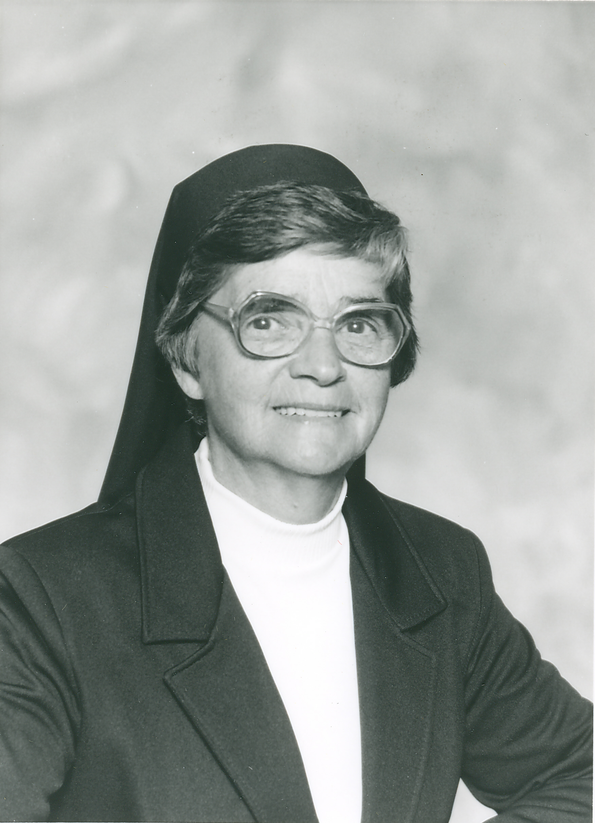

Sister Monique Gobeil
(Sister Monique of the Passion)

December 2, 1924 - February 19, 2015

“What good is it to profess faith
without practicing it?
Such faith has no power to save one
has it?”
(James 2:18)

Georgette Alice Gobeil was born on December 2, 1924 in Ste-Julie, Quebec, Canada to Leon of Lyster and Marie-Anne Pare of Plessisville. She was the tenth child born in the Gobeil family of four boys and six girls. Georgette was the youngest of the family for four years until the arrival of her baby sister.

Her father was a carpenter by trade. He built the school of Ste-Julie which the Gobeil children attended. Her mother was a housewife who loved and cared for her large family. As a child Georgette was very happy and active. She also could be quite mischievous. Her mother always referred to her as her “tomboy.” Little Georgette found it hard to sit still in school and didn’t like school for she found it to be boring. She began working at the age of fourteen years for the Good Shepherd Sisters. She worked in the laundry with them and helped with the cleaning. She was very edified by the Sisters whom she found to be hard workers who also prayed with the girls employed by them. She found their lifestyle very simple and prayerful and as a result, she was moved to join them in religious life.

On August 25, 1941, Georgette entered the Novitiate of the Good Shepherd Sisters in Quebec. She pronounced her first vows in 1943 and was given the name of Sister Monique of the Passion. Sister Monique was the name she used during her entire religious life and it held a very deep religious significance for her.

Her assignments as a young sister were often kitchen or laundry work. Neither of these assignments appealed to Sister Monique. She requested to be assigned to the United States for she could somehow identify more with the mentality of the American Sisters. It was understood that every three years she could return for a visit to Quebec where she would have the chance to see her loving parents and siblings. Once settled in, she wanted to spend all of her religious life in the United States. She completed her education by a Correspondence Course offered by the American School and earned her high school diploma this way.

Sister Monique worked at many different ministries during her lifetime: Certified Nursing Assistant at the local hospital, parish ministry in Biddeford and Grand Isle, Maine, and sewing in the Biddeford Mills. She never refused to help others in need if she possibly could be of assistance. She had many artistic and practical gifts which God gave her and she shared them most generously. Sister Monique seemed to hear a different drummer and was given permission by those in authority to follow her “special” calling. She describes it in her own words.

Here are my thoughts of my “special ministry” which is, I think, my daily apostolate which I accomplish, with the grace of God, and where I hope to do good to everyone I encounter along my way. You know that I worked full-time at Hanold Company where I was employed sewing sports clothing. It is, therefore, in a mill that I accomplish my apostolate, my “special ministry.”
I was inspired by James 2:18-19 whom I quote:

My brothers (and sisters), what good is it to profess faith without practicing it?
Such faith has no power to save one, has it? If a brother or sister has nothing
to wear and no food for the day, and you say to them, “Good-bye and good
luck! Keep warm and well fed,” but do not meet their bodily needs, what good
Is that? So it is with the faith that does nothing in practice, it is thoroughly life-
less. To such a person one might say, “You have faith and I have works—is that
right?” Show me your faith without works, and I will show you the faith that
underlies my works.”

This is how I understand my ministry to souls. If we wish to reach their souls, we must first meet their bodily needs. My “special ministry” is to simply, at my work with them, exemplify a woman of faith with convictions that the Good Lord loves us, whether a religious, married person, or parent of a family. In other words, we form one big Christian family—the Mystical Body of Christ. As we live our daily lives, we complete what is lacking in the Passion of Christ. I give the persons who approach me, in their simple lives and in their own understanding, assurance of the love God has for each and every one of them. For me, the time of sermons is past. My actions help me to develop faith in simple souls who wish to receive Christ in their lives, wish to understand His message and to imitate His life in their own lives, and in their daily work. They need great faith so they will not become discouraged and lose confidence in God who wants the best for His children.

For me, I find the apostolate of our times in being all to all! If it is a poor person, try to find the material goods needed. If it is an alcoholic, try to be good, patient and await the time he/she can attain sobriety. If it is a professional, accept him/her as they are.

Often, after work, I visit the homes of the elderly and families in need of all ages and categories. I try to give them the material goods they lack; at times, I help them find employment; a home to rent; or inform them of courses or programs to better their situation in life.

In summary, these are some of the works that form my “special ministry.” I try to live their lives with them and get into their skin as best I can. I try to, like Christ, spend my time doing good with simplicity and love. I would love to see a house established to help the poor—material and spiritual. Like Christ, I attempt to meet their material needs then their spiritual needs. As a disciple of St. Paul, I hope to be able to say: “My life is Christ.”

One of our Affiliates, Cecile Casey, resides in Madawaska, Maine. She was instrumental in another of Sister Monique’s “special ministries”. In her own words she describes the ten years she hosted Sister for her years of ministry in Madawaska, Maine.

I had the unique experience as well as the good fortune and honor of having Sister Monique reside with me for over ten years as she continued her dedication, devotion and commitment to her ministry in the St. John Valley in Northern Maine—which is where she left her heart. She dedicated and devoted her time and talents helping the poorest of the poor, working and caring for the elderly, the unfortunate, the lonely, the sick and the needy. She was always available to lend an ear or a hand to those who were lonely and needed someone to talk to.

Sister Monique chose a very simple lifestyle. Her dedication to her work was an inspiration to anyone and everyone who crossed her path, whether they became close acquaint-
tances or passersby. She gained total respect from everyone who knew her. No matter who called for help, be it painting, planting flowers, wallpapering, working with the farmers in the potato fields getting the seeds ready for planting. What she did and how she did it proclaimed her true commitment, dedication and devotion to doing Christ’s work. Sister never sought recognition, personal fulfillment, or personal satisfaction for dedication to hard work. She felt powerless but relied on God for her every work and need she undertook.

Sister Monique accepted her vow of obedience with commitment, dedication and devotion. Therefore she became one with the poor and powerless in a special way as Christ did in His Passion. She knew what it was to stand in need before God, to love as Jesus did and to work on God’s Plan with Him.

She was a voice for those who were unable to speak for themselves and that furthered her religious witness. She especially had a soft spot for the elderly, the sick and the marginalized thus further proving her continuation of the Passion which she lived. Her compassion for everyone she met as she counseled the sick and suffering was beautiful. As a result, through her, they would experience God’s healing presence.

Sister Monique asked for so little yet gave so much. She took great joy in and truly appreciated the small things of everyday life. Her immense and deep belief, devotion and faith in the Good Lord was unquestionable. She was always praying for one or another.

From personal experiences, I know that if she was praying, things would start happening. So many people got to know her, many just from the prayers she offered in their name. How great to have such care, dedication, devotion, commitment and faith. She would say, “If it is asked, it will be answered.”

Sister Monique had such immense faith and she believed so deeply, I think it speaks to what kind of person she really was to all of us. As she became ill and feeble, we rushed to her bedside and continued to be by her bedside day in and day out until her final moment when the Good Lord carried her to a better place. So many Sisters came to hold her hand and comfort her in some dark moments. She was a true example and deep inspiration of love, dedication and devotion of true faith to all of us. I realize today even through her suffering and death, she will continue to give us the gifts we all need. I am so thankful I was able to sit with her these past few days, spending her last hours with her. It has been a gift and an inspiration beyond measure. I believe I can now say I know a little more about living and dying than I used to. As I observed the Sisters, in the way they held her hand and comforted her, I am beginning to grasp the concept of grace. As I continued to observe the dedication of each caretaker meeting Sister Monique’s needs with love and compassion, I appreciate the value of service toward others even more. In time spent in communion with Sr. Monique and the other Sisters, I have relearned a bit more about faith and trust. I am reminded of the value of holding friends and family close and the tremendous strength that comes from such gentle caring for one another. I will forever be grateful for having known Sr. Monique Gobeil and so will everyone who has come to know her.

Another lay employee at Good Shepherd Pavilion befriended Sr. Monique and at the Prayer Service on the eve of her Mass of Christian Burial shared the following:

Sr. Monique was a graduate of the “School of Common Sense.” She believed that people don’t care how much you know, they need to know how much you care. She had the ability to accept people for who they were and where they were in life. She lived and worked with people and understood them. She was proud, yet humble. She was dedicated and always ready to be of service. She was private, but open and welcoming.

I thank her for her friendship, her insight, her loving spirit and her words of wisdom. She was a blessing in my life and in the lives of many others—the many lives she touched over the years. It was an honor and a privilege to know such a great woman of all seasons!

When Sister Monique was a patient at Maine Medical Center in Portland, Maine, one of the hospital chaplains, Father Robert Vaillancourt, recognized her name and remembered her from the time he was pastor of the church in Madawaska, Maine. He visited her soon after she had received her diagnosis and offered her the Sacrament of the Sick which she greatly accepted and appreciated. At the time of her Mass of Christian, Father Vaillancourt officiated at Sister Monique’s beautiful Burial Mass. His homily was very personal as he spoke of her ministry to the people of Madawaska. A few quotes from his homily follow:

Sister Monique helped to build the Kingdom of God for 90 years. She knew that without her Spouse she was nothing. She lived and died with the Lord so that others may live. All of her life was for others so that they may life. The name she received in religion, Sister Monique of the Passion, says it all. It was not her passion, but the Lord’s Passion where she found her strength, her focus, her direction, her CROSS. What a name she chose! What a privilege!

Truly, “The souls of the just are in the hand of God, and no torment shall touch them—for they are at peace.” Today, Sister Monique’s hope is full of immortality as expressed in the second reading from Romans. “If we die with Christ, we believe that we shall live with Him. Sister Monique lived 90 years dying for her Lord so that others might live. May she now rest in peace with her Beloved.

Sister Monique ended her life on earth on February 19, 2015 and her Mass of Christian Burial was celebrated at St. Joseph Convent on February 24, 2015 with Reverend Robert Vaillancourt, Chaplain at Maine Medical Center, Portland, Maine, officiating and giving a very personal homily. The burial took place at St. Joseph Cemetery in Biddeford, Maine.

Sister Sharon Leavitt, s.c.i.m.

Fourth Sunday of Lent
March 15, 2015

