BIOGRAPHICAL SKETCH

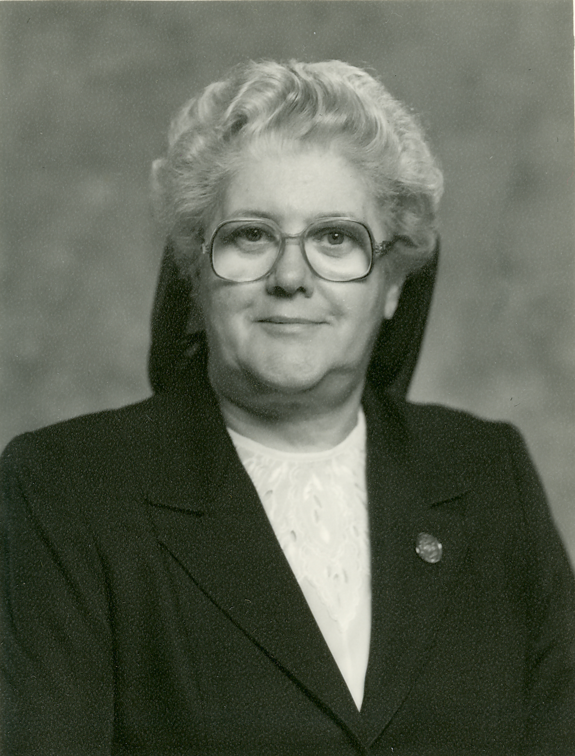

Sister Anita Therrien
(Sister St. Pauline of the Redeemer)

February 6, 1924 - April 10, 2016

“I saw a new heaven and a new earth.
The former heaven and earth had passed away,
And the sea was no more.
Behold, I make all things new.”
(Revelations)

On April 10, 2016, Sister Anita Therrien, formerly known as Sister Pauline of the Redeemer saw a new heaven and a new earth. Her journey of 92 years ended and St. Joseph Province lost a woman of clear vision and courage who joined her God in heaven. As promised in the Book of Revelation, “the Lord will be her Redeemer and she will be His own.”

Sister Anita was born in Lawrence, Massachusetts to Adelard and Albea Letarte Therrien. She was the first-born on both sides of the family, so she received lots of attention from all her relatives. There were three girls in the family and they all enjoyed a happy family life. She received her schooling at St. John Baptist School in Methuen and at St. Anne High in Lawrence. All of her teachers were Good Shepherd Sisters whom she loved.

Sister Anita was a born teacher. Even as a child, she “played school” with her younger siblings and cousins at home, using little desks constructed by her father. Her parents placed great trust in her and knew they could leave younger children in her care. As a teen-ager just graduated from high school, she was employed as bookkeeper and cashier in a boys’ clothing store in Lawrence.

She had decided to enter the convent during her high school years. In 1944, two years after her graduation, she entered the Novitiate in Biddeford, Maine, despite her parents’ tears. One of her best friends, Loretta Morency, entered with her. She enjoyed her formation years.

After her vows, Sister taught in elementary schools in Biddeford and Old Town, Maine, for three years. Next, she was assigned to the Mother House in Quebec where she studied for a year at Laval University. From this assignment, she went to Van Buren where she taught in the Public School System for three years. She was then transferred to Biddeford where she became principal of the elementary school. She taught in St. Joseph High School in Biddeford and later became Principal of St. Joseph High School.

Sister Anita was named Provincial of St. Joseph Province in 1970. She served the Province in the very crucial post-Vatican II years of change and upheaval. Her clear vision and courage were put to great use during this period of Church and Province renewal. Parochial Schools were closing during these years for lack of funds, and many Sisters were discerning their vocation in religious life. This was the case in many religious communities in the country at this time in the history of the Church. Sister Anita, with her vision, sought a program to aid in these years of transition. The choice made was with Saint Louis University’s Jesuit-Sponsored “Institute of Internal Resources for Renewal (IIRI).” This was referred to as “The Corporate Renewal Program.”

A team of five Sisters was elected to be trained by IIRR faculty in the theory and practice of the Corporate Reflection Process—a renewal program for post-Vatican II religious communities. This well-trained team then held meetings and workshops for the local communities of St. Joseph Province. Great emphasis was placed on the spirit and social emphasis of our Foundress, Marie Fitzbach Roy. With parochial schools closing, Sister Anita directed several sisters toward works of mercy which were evident in the roots of our Good Shepherd Congregation.

In this same spirit, in 1973, Sister Anita answered the Bishop of Maine’s appeal to religious congregations to send missionaries to Brazil to help educate the poor people there longing for education and to hear the Word of God.

Another crucial phase of leadership in the life of Sister Anita was the great social transition concerning unwed, pregnant women. St. Andre Group Home was opened in 1940. However, the changing social needs resulted in a facility this size to be no longer necessary. A studied response brought forth the concept of small group homes. Sister Anita oversaw this transition and by 1973, St. Andre Group Home was vacant, and three group homes were established in the State of Maine. A task force was established to discern how we could best meet the social and spiritual needs of the Biddeford/Saco population. This lead to the establishment of St. Andre Health Care Facility in 1976. Sister Anita was instrumental in the establishment of St. Andre Health Care Facility which opened in 1976.

Her next venture, which was from 1987 to 1999, involved the complete renovation of the second floor of Bay View Convent which became Villa Muir (Bed and Breakfast.) It took courage and a good dose of resourcefulness to take over the renovation of these guest rooms for ladies and gentlemen seeking the peace, beauty and repose which this, our home by the sea, could offer. Sister’s skill in meeting this situation is to be admired. Long hours of planning, researching for appropriate supplies and furnishings, finding the best and most economic companies to do business with resulted in many simple, but attractive Villa Muir guest rooms. However, the secret of why people wanted to return again and again lay in the gracious and understanding reception which Sister Anita gave to all her guests alike, be they vacationers, retreatants, or students. Her personal touch endeared her to all, and they returned for more. She directed this final venture as long as her health permitted.

Sister Anita graciously accepted her transfer to Good Shepherd Pavilion when extra care was needed. She was never one to complain but took life in stride singing very frequently her favorite theme song: “Que sera, sera!” Whatever will be, will be, the future is not mine to see, “Que sera, sera!”

On February 2, 2016, Sister celebrated her 70th anniversary of vows at a festive Liturgy and banquet. A fall in her infirmary room on December 8th made life more difficult for her in her last months of life. The death of her dear sister, Lorraine, about a month before her decline also caused her great sorrow. On April 10, she peacefully left us for her heavenly reward.
.
On April 14, 2016, Reverend Joseph Manship celebrated her Mass of Christian Burial. Her sister, Mrs. Evelyn Bergeron and several nieces and nephews attended the service at St. Joseph Convent. The organ music was provided by her best friend, Loretta Morency’s grandson, Christopher Pelonzi.

Reverend Joseph Manship delivered the inspiring homily from which I will now share several quotes:

“In the fullness of time” is the phrase that comes to mind this morning as we gather to pray for our beloved Sister Anita. This day is truly the “fullness of time” for her. It is the day she goes to the eternal “dwelling place” where her Redeemer awaits her. Even as we gather with a certain element of sadness at being separated from her, that sadness is mingled with a deep serenity and a quiet gratitude for her life.

When we say before God that we are thankful to have known and loved someone like Sister Anita, we are in fact thanking God for revealing something of himself yet again in human form. It was only in Jesus Christ that we saw the glory and goodness of God fully shining in a human face. And, yet it is also true that in the goodness of every human being there is another different revelation of God—incomplete, flawed, but nevertheless, a mirror of His love. Why, as I said, is our mourning mingled with such quiet gratitude today? Because we have been in the presence of someone who helped us to glimpse God.

Borrowing a word from another religion, would it be too much to say that everyone is called to be a “re-incarnation” of God? Did not St. Paul say: “Not I that live, but Christ that lives in me”? We are here in this life to echo the life of Christ, to grow in wisdom and age like him, to reach out like him in healing the wounded of the world, to love children, to have compassion for the weak and suffering, to make our hearts known to our friends, to take up our crosses, to forgive others and to be forgiven, to find our mountain top places for prayer, to have the courage to oppose evil. This litany could continue but these facets of Christ himself are alive for us today because we glimpsed them in the struggling life and love of Sister Anita. Struggling because, like all of us, she was imperfect, yet, a struggling love because through a long life she learned from God to let go of herself as she lived for others. And now she has let go finally.

A good part of her younger religious life she reached out to young people after obtaining the necessary education, degrees and credentials to be a competent teacher, although, I think she probably was a natural born-teacher.

Sister Anita was a leader who had vision, courage and was not afraid to take risks. All the while, she was a playful people person who was considerate, grateful and discreet and yet not above eating a good plate of fried clams with a beer. She enjoyed a game of Beano, Carems, and was a faithful follower of the television game show, “The Price is Right.”

Her vocation to religious life was not about the seeking of self, but rather the seeking of God. The only reason for this choice in life is to seek to know God’s will and to contribute to the building of the kingdom of God where God is known, loved and served.

As a Good Shepherd Sister, Anita was a woman who lived, ministered, and prayed with and in the world. As a religious, she was called to live an “active” or “apostolic” life. She was engaged in the works of mercy and other ministries that brought the Good News of the Gospel to others where they were at—wherever there was a need.

Our consolation today comes from gratitude for Sister Anita, for God in her, for Christ glimpsed through her. But, our deepest consolation comes in the faith that looked through death (as Wordsworth said) in the hope that gathers us here, the hope that as Sister Anita shared in Christ’s life and now shares His death, so she will also belong in His new life dwelling in the place He has prepared for her. Amen.

We return once more to the Book of Revelation as we bid farewell to dear Sister Anita. “God will wipe every tear from their eyes, and there shall be no more death or mourning, wailing or pain, for the old order has passed away.”

“The one who sat on the throne said, “Behold, I make all things new. I am the Alpha and the Omega, the beginning and the end. To the thirsty I will give a gift from the spring of life-giving water. The victor will inherit these gifts, and I shall be her God, and she will be my own.”

Sister Sharon Leavitt, S.C.I.M.

Feast of Pentecost
May 15, 2016

