BIOGRAPHICAL SKETCH

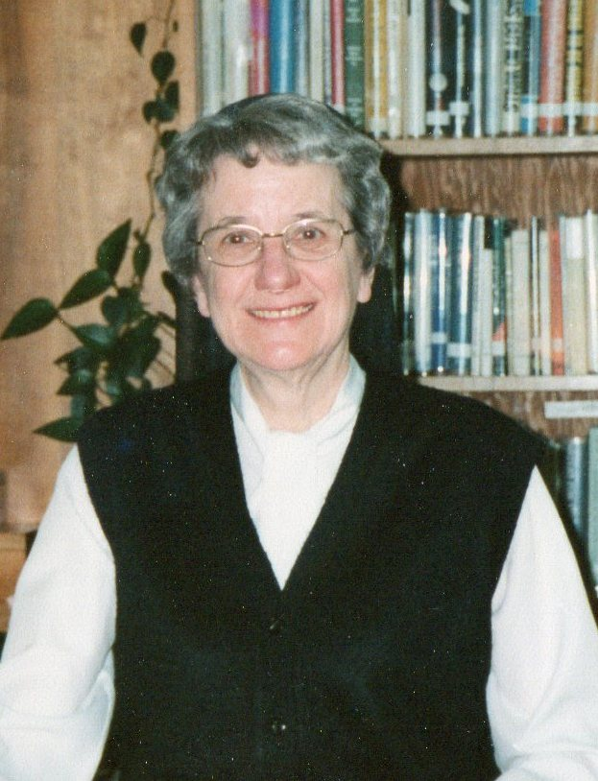

Sister Aline Madore
(Sister Aline-Marie)

December 25, 1921 -- December 19, 2007

...For you created my inmost being;
You knit me together in my mothers womb...
My frame was not hidden from you
When I was made in the secret place.
(Psalm 139)

In the beautiful, snow-covered St. John Valley of Northern Maine as the voices rang out the traditional French Christmas Carols heralding the birth of our Savior, the voice of a new-born was heard, that of little Aline Claire Bernadette Madore. Later, on that Christmas Day in 1921, Aline was brought to St. Bruno Church to be baptized.

Alines parents, Louis Madore and Demerise Ouellette, were both born in Van Buren, Maine. Her father was a carpenter by trade and her mother was a housewife. There were four boys and three girls in the Madore family. Only four of these children reached adulthood. Aline was the sixth child of the family and the youngest surviving member.

Sister Aline shared that she had a happy childhood, surrounded with much love and affection. She was brought up in a pious and Christian atmosphere. She attended Sacred Heart School in Van Buren until the sixth grade when, during the Great Depression of the 1930's, the family moved to Lawrence, Massachusetts. She attended St. Joseph Elementary School and High School which was also staffed by Good Shepherd Sisters. She graduated from St. Joseph High School on June 16, 1940.

Aline always remained very close to her parents and her to former teachersthe Good Shepherd Sisters. She, along with her friends and classmates, enjoyed spending many hours with the Sisters helping them after school.

Sister Aline recounts that when she only five years old and attending kindergarten, she met her first teacher, Sister St. Adele, who gave her a love for teaching. When she was very young, she enjoyed playing school with her little friends. She tried to imitate the two teachers whom she admired most, Sister St. Adele and Sister St. Antoinette.

Persons who influenced her vocation the most, she continues, were her mother and her father who were outstanding Christiansliving examples of a life of simplicity, faith in God, and acceptance of Gods will. She shared that they had a true love for each other, and a loving devotion towards their children. They were both daily communicants and were self-sacrificing and active members of the Legion of Mary for twenty years. In Sister Alines judgment, her parents were holy and saintly enough to be canonized.

Sister found that her teachers, the Good Shepherd Sisters, were excellent examples and influenced her choice of religious life. She admired them and was impressed by their way of life. She knew she wanted to imitate them. The desire to enter the convent began in kindergarten when she first said that she wanted to become a nun and teach children. This desire did not leave all through her school days. Five of her friends in high school felt called to religious life also.

On May 16, 1940, Aline wrote her letter to Mother Mary of St. Vital, Provincial Superior, requesting entry to the Novitiate. She assured the Provincial that she would do all she possibly could to be faithful to the voice of God who called her to save souls. She promised to be a pious and obedient religious. Those of us who knew Sister Aline and who lived with her feel that she kept this promise all her life.

In August, 1940, Aline entered the Servants of the Immaculate Heart of Mary Novitiate in Biddeford, Maine. She was very lonesome for home and family at the beginning. She developed a sore knee during her Postulancy. She thought that maybe she would be sent home because of this affliction (as did the Mistress of Novices). However, when her parents came to visit her, they encouraged her to remain and promised to pray for the healing of her knee. Her knee healed and she never again thought of leaving the convent! She shared that she always felt happy and at home in her vocation from that point on.

On entering the convent, Sister Aline shared, she wanted to live with people who loved God and wanted to help others to love the Good Lord also. The Sacrifice of the Mass and Holy Eucharist and the remembrance of the good example of her parents gave her the strength to draw ever closer to her Spouse. She was greatly influenced by the spiritual exercises of the Novitiate and the formation given. She also profited greatly from her year at the Mother House in Quebec. Her studies at the Scholasticate and the many devout Sisters with whom she lived in community all had a great impact on her religious life.

In 1942, at her first profession, Aline took the name in religion of Sister Aline-Marie. Her first assignment was to St. Theresa School in Methuen, Massachusetts in 1943. In 1944, Sister Aline returned to the place of her birth, Van Buren, Maine. She taught in the schools there until 1954. Next, she became a full-time student at St. Joseph College, Windham, Maine, where she earned her Bachelor of Arts degree in 1955. From here she taught at St. Anne High from 1955 to 1957. Next, she was Principal at St. Anne High School in Lawrence, Massachusetts from 1957 until 1965.

During several summers, Sister Aline and Sister Doris Gallant volunteered at the Lourdes Bureau in Boston which was run by the Marist Fathers. After several years of volunteer service, they were invited to accompany a pilgrimage to Lourdes, France, to help the sick and handicapped on the trip. They were very happy to render this service and were very grateful to have the opportunity to visit this beautiful shrine.

Sister was Principal at St. Joseph High in Biddeford, Maine from 1965 to 1968. She next became a full-time student at Boston College where she earned her Masters Degree in Guidance.

Upon her graduation, Sister Aline again returned to her beloved St. John Valley and remained in the School District there from 1968 to her retirement in 1991. She served two terms as local superior of St. Bruno Convent. Administrators, faculty, parents and students all loved and appreciated her loving concern, sincere interest and devotion to all. She spent a total of thirty-three years in the Van Buren School District.

Sister Aline served as a member of the Board of Directors of St. Andre Home, Inc. from 1992 to 1996.

A testimonial written by a Sister who first met Sister Aline in the Novitiate (though they were both born in Van Buren) gives ideal insight into the beautiful person that Aline was. The ideal description follows:

Sister Aline was what she was: A person whose simplicity, warmth and sense of humor pierced right through to everyone.

As we journeyed together for several years of religious life, her list of qualities and character traits grew. To the original list already mentioned, I add: a strong faith, patience, kindness, and positive outlook. These are just a few and there are many more.

Anyone who has lived with Sister Aline knows that her favorite invocation is Dear Jesus! Whether she had to confront a big ordeal or a smaller one, Dear Jesus is on her lips. She gratefully attributed any success to her loyal Spouse, her dear Jesus.

There is no need of anecdotes to prove Sisters kindness, patience, prayerfulness, and sense of humor. We witnessed these daily in her actions and devotedness. Her sense of humor kept her in good spirits and also kept the rest of us in stitches.

In closing this jubilee testimonial, let me cite what one of our Sisters who is a close friend of Aline told me. Without effort, Sister brings joy by being what and who she is: A person of great faith and beautiful simplicity. In all the many important posts she occupied, she touched many souls who all remember her fondly.

A testimonial, given by her nephew, Gilbert Frechette, attests to the wonderful impact her life had on his generation. Quotes from his testimonial follow:

Aline Madore was a bright, selfless, outgoing woman of faith who always thought of others and showed it by her many kindnesses. She had two families to love and who loved her. She was a great correspondent writing many letters to the family.

She was completely devoted to her life as a member of this community. ...Her thoughtfulness and consideration spanned generations...She lived life with abandon, trusting completely in Gods mercy and protection. She was always happy with her life, no matter where she was or what her job was. She was especially happy at Bay View for she loved the beach.

Sister Aline accepted what God had planned for her without question. It had to be so hard for her to be so confused. It was also hard for us to see!

Tante Aline, Sister Aline, we rejoice that, free from your physical bonds, you were able to run to see the members of both of your families waiting, with your (Dear Jesus) for your arrival. Now there is no more wondering with whom you are speaking; no more struggling to remember; no more confusion; no more fear and no more pain. We are going to miss you, even though we know you are always with us in spirit. We look forward, in Gods time, to our next meeting. We all love you!

As the years passed, Sister Aline was becoming very forgetful. In 1991, she decided that it was time to retire from education and move to Bay View Convent. She loved the ocean and took long walks along the beach and around the grounds of Bay View. Never one to remain idle, she gladly was of service at the Villa where she helped prepare the rooms for the guests. Her memory continued to fail her however and in 1998, it was felt that she was in need of more care and supervision to be kept safe. So, difficult as this final transition was, she accepted it as the Will of God. Among her personal belongings, she left a few of her final prayers which follow: It is faith that tells me most surely that Jesus is really present in me...more present than if He were standing before me visible to my bodily eyes. Another prayer is: You, Lord, are all I have! You give me all I need. My future is in your hands. How wonderful are your gifts to me! How good they are! Her final written prayer follows: God goes with me, kindling my heart and illumining my mind only if I put myself in Gods path, only if I let myself be led, taking things as meant, looking for signs, letting my heart speak, setting out on the way that opens up before me...and that takes courage!

Joyce Smith, former Director of Nurses at our Good Shepherd Pavilion, also wrote a tribute to Sister Aline. Excerpts follow:

The Christmas Present

Who would have ever guessed, centuries ago,
As Jesus lay in the mangers hay,
That the deeply spiritual, Aline,
Would also be born on her own Christmas Day?

Perhaps this accounts for
All her special, gentle devotion
Her charity, and lack of negativity,
That kept her teaching, counseling, and superior
roles all in motion.

Her humble Jesus devotion
Began all conversation...
Dear Jesus, sweet Jesus, help me!
Crippled in later life,

She walked tall with her rod and staff.
Till finally, bedridden and worn,
A stillness stopped her smile, her laugh.

Now, quietly, she has slipped away,
Apparently, God wanted His own present
This Christmas Day,
Calling His devoted Aline home,
On their mutual birthday!

How appropriate the following poem seems for Sister Aline spent her 86th birthday in heaven. Following are a couple of stanzas of this poem:

Christmas in Heaven

I see the countless Christmas trees,
around the world below,
With tiny lights, like Heavens stars,
reflecting on the snow.
The sight is so spectacular! Please wipe away that tear,
For I am spending Christmas with Jesus Christ this year.

I send you each a special gift
from my heavenly home above.
I send you each a memory of my everlasting love.
After all love is the gift, more precious than pure gold,
It was always most important in the stories Jesus told.

Please love and keep each other, as my Father said to do,
For I cant count the blessings of love Jesus has for you.
So have a Blessed Christmas and wipe away that tear,
Remember, I am spending Christmas
with my dear Jesus this year.

A prayer service was held at St. Joseph Convent on December 21, 2007. Sister lay peacefully beside the beautiful Christmas tree as friends and family reminisced about her great contributions to the people of God and the many gifts she possessed and so generously shared all her life.

On December 22, 2007, at our Bay View Chapel, the funeral service for Sister Aline Madore took place. The officiant at the Mass of Christian Burial was Reverend Hubert Paquet who was assisted by Reverend Richard Knox and Reverend Normand Richard, who delivered the homily. Several nieces, nephews and friends were also present at this service.

Sister Sharon Leavitt, S.C.I.M.
January 13, 2008

