BIOGRAPHICAL SKETCH

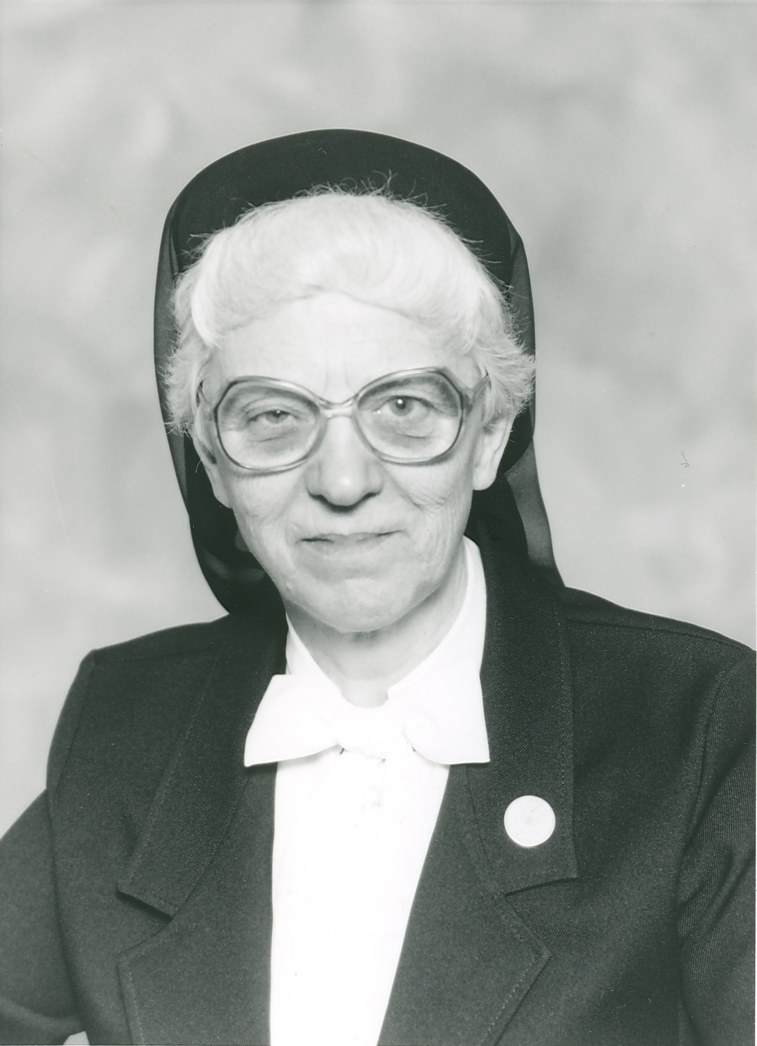

Sister Aurore Beaulieu
(Sister Marie-Claude)

January 7, 1922 - November 27, 2017

1732nd death

“The Lord is my shepherd, I shall not want…
Even though I walk in the dark valley
I fear no evil; for you are at my side.”
(Psalm 23)

The St. John River forms the natural boundary between New Brunswick, Canada and Van Buren, Maine. This land forms the beautiful, peaceful St. John Valley of Northern Maine. From Van Buren, the Good Shepherd selected a quiet, shy worker for the vineyard in the person of Aurore Beaulieu.

Sylvain Beaulieu of Grand Isle, Maine wed his spouse, Lucie (Cyr) Beaulieu from Eagle Lake, Maine and resided in Van Buren where Sylvain was employed in the local saw mill. He provided well for his family of seven children. The family worshiped in St. Bruno Parish and all the children attended the local parish schools. Joy and love reigned in the Beaulieu family. On weekends they would gather on their front lawn to play music and sing with neighbors and friends who were welcomed to join in the merriment. Sister Aurore played the piano by ear and could entertain others by playing for them any tune she had heard. Aurore never took piano lessons.

The first born of this couple was Leonard who was followed by Ethel, Anita, and Rena. Then came the twins Aurore and Albert who were born on January 7, 1922. Following the twins was another little girl named Theresa. Legend has it that Aurore held her twin brother’s foot at his birth. Actually, Aurore recounts that her twin brother tagged along beside her throughout their childhood. Albert was not the scholar that Aurore was and she recalls that she had to “drag” him to school. When it was decided that he should repeat a grade, that chore changed for Aurore. In 2001, her twin brother died at the age of 69 years of a heart attack.

Aurore was very quiet and shy as a child. She shared that she knew what she desired to be when an adult at the very tender age of three-years-old. She wanted to be nun and couldn’t wait to be a “big girl” so she could enter the convent.

Aurore graduated from Sacred Heart High School and wanted to enter the convent that fall. However, due to her frail health, she was asked to wait a year. Her friends gave her a going away party before she left for the convent the following year.

Her Postulant and Novice years were a strain on her physical strength and health. On the eve of her first vows, she decided that she needed to return home for a year of rest. Her group of twelve novices were sad to see her leave, but she felt she really needed to rest. Following that year with her family, she re-entered and continued her formation time with the Good Shepherd Sisters. She pronounced her first vows on August 15, 1945. Her name in religion was Sister Marie-Claude.

Though of frail health as a young religious, she lived to the ripe age of ninety-five years! For several years she had the honor of being the most senior member of St. Joseph Province. She was very proud of this fact and frequently reminded us of it.

From 1947 to 1973, Sister Aurore taught in elementary schools in Massachusetts and Maine. She was an excellent teacher and her students fondly remembered her. She was very patient with the slower students and one former student recalls her singing to a distraught student “I never promised you a rose garden”.

Sister Aurore was a very close friend with another Northern Maine native, Sister Annette Bouchard. They loved to prepare their classes together. Sister Annette said that the classroom decorations prepared by Sister Aurore were incomparable. In their retirement years, they grew old together at St. Joseph Pavilion. It was very interesting to hear their exchanges of the “good old days”. A highlight of Sister Aurore’s spiritual life was when she and Sister Annette Bouchard traveled to Minnesota to make a directed retreat with their spiritual director, Ms. Christine Malone. Sister dearly missed her good friend, Sister Annette, who died in 2015.

In 1973, Sister Aurore was transferred to the Sisters’ Residence of 696 in Lawrence, Massachusetts, where a seamstress was needed to make and repair clothing for the many children of St. Anne Orphanage. For ten years she provided this service to the children. Her skill at sewing was excellent and she was greatly appreciated in that field.

During this period of time, she also was a part-time receptionist a few evenings a week in the Office of Catholic Charities of Massachusetts, where she typed case histories for their counseling service. At Christmas time she worked as a volunteer with the Salvation Army preparing lists for those in need.

In early 1991, Sr. Aurore was transferred to Bay View for health reasons. She was busily employed here as a receptionist and she also used her creative skills in sewing to become a great contributor to the Bay View Gift Shop. She fashioned very attractive, original aprons that sold very quickly at the Gift Shop. She was renowned for them.

As Sister Aurore’s health declined with age, she was happy to transfer to the Good Shepherd Pavilion in 2008. She stated that she loved all the nurses very much and was happy to have been among the first to arrive here before the closing of the Bay View Convent. She kept busy using her creative skills as long as she could.

Sister Aurore could be seen in the hallways of the Pavilion using her walker to maneuver her way to chapel where she spent many hours in silent, prayerful adoration praying for vocations and priests.

She would pay frequent visits to Sister Annette Nadeau, her Superior. She often was too tired for the return trip to her room, so Sister Annette would let her ride on her motorized chair and Sister Annette would use Sister Aurore’s walker instead to accompany her back to her room. In good weather they took similar short trips together around the convent in motorized chairs. Sister Aurore had a smile on her face and kept her good sense of humor throughout her later years.

She realized that her journey was about to end on earth and did her best to prepare to meet her Good Shepherd. She was good friends with our former Chaplain, Father Normand Richard, who was now retired but came to the convent three days a week to celebrate liturgies. Father Norm helped her greatly in last weeks of life on earth.

Sister Aurore breathed her last breath on November 27, 2017 in the early hours of the morning. (Aurore in English means Dawn) and the sunrise a few hours later in early dawn was a most breathtaking sight as the sky turned a beautiful shade of pink and red which was also reflected in the flowing Saco River bordering St. Joseph Convent.

Reverend Normand Richard celebrated her Mass of Christian Burial on December 4, 2017, at St. Joseph Convent during the first week of Advent. He also gave the homily at the Mass. Several nieces and nephews attended this service at St. Joseph Convent.

I am concluding Sister’s biographical sketch with several quotes from the homily given by her good friend and celebrant, Reverend Normand Richard:

When we think about the life of Sister Aurore, we recall a beautiful person who walked humbly these halls and died so close to the Advent season. She made sure that she was well-prepared for her death and when the time came for her to say her final yes to God’s Will, she left this earth very peacefully. Sister Aurore could not have died at a better time in her life. She was able to attend Mass daily almost to the end of her life and to walk the halls of the convent, never hesitating to smile and greet those she met along the way. She made sure that all aspects of her life were at peace. I had the gift of watching her search her life from the time she was a little girl in Northern Maine to the present. Sister Aurore loved the Lord and she made sure that she was prepared for her final journey.

For Sister Aurore, she is now beyond all of these practices and traditions. She no longer lives in time as we do, rather, she belongs to eternity. How truly blessed she is! We have certainly been blessed to have known such a wonderful person. She radiated the love of God and appreciated the many little facets of His creation that crossed her path daily. She was a woman of great faith! In her better days in Bay View, she enjoyed making us laugh when she would sing her little tune about “La Petite Aurore”.

Today, as we come to pray for the repose of the soul of Sister Aurore, we know that we have encountered a very good soul. To us she was a beautiful reflection of the love of God which touched her and radiated from her. When thinking about Sister, endearing words come to mind such as, gentle, quiet, gifted, unassuming, successful, creative, religious, prayerful and an accomplished seamstress. Sister Aurore was small, like Zaccheus, but she too was strong in her faith and was blessed with a full and long life. She had waited a long time for her death to come and she was fully prepared for it. It must have been quite a scene in heaven when she came face to face with God the early morning of November 27, 2017. Her dear parents, her six siblings—especially her twin brother, Albert, Mother Foundress and the many other Sisters who preceded her in death must have had a wonderful reunion in heaven when Sister Aurore joined them!

Today, we give thanks to God and place Sister Aurore into His hands. As Jesus said to His disciples in the Gospel reading from John of today, “Do not let your hearts be troubled. You have faith in God; have faith in me.” Sister Aurore no longer has any fears. May her soul and the souls of the faithful departed rest in peace. Amen

Sister Aurore Beaulieu was buried in St. Joseph Cemetery in Biddeford, Maine on December 4, 2017.

Sister Sharon Leavitt, S.C.I.M.
Martin Luther King, Jr. Day
January 15, 2018

