BIOGRAPHICAL SKETCH

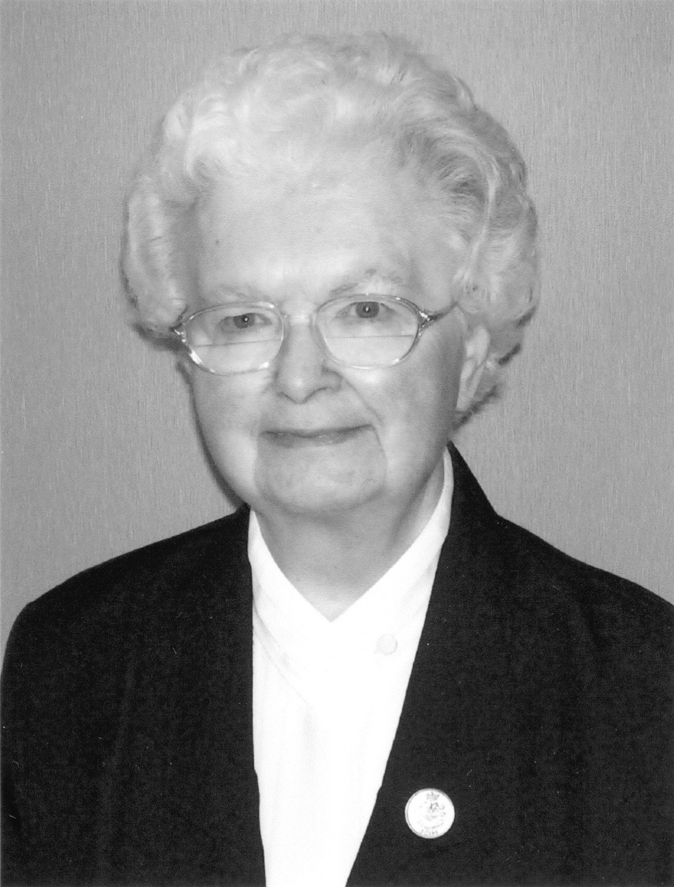

Sister Jeanne Soucy
(Sister Marie Jeanne Therese)

April 12, 1925 - July 25, 2013

“I love the Lord because he has heard
my voice in supplication,
Because he has inclined his ear to me
the day I called.”
(Psalm 116:1 & 2)

Sister Jeanne Soucy (in religion, Sister Marie Jeanne Therese) was born in Grand Isle, Maine on April 12, 1925 to Patrick Soucy and Suzanne Lavoie Soucy. Both parents were natives of Grand Isle. Her father was a farmer and her mother was a housewife. Jeanne was the thirteenth child born in the Soucy family. Though her mother delivered seventeen babies, only eight survived infancy. The great depression took a terrible toll on her family. Her father lost their farm and home, even their cow, during this time of great trial. Her father then became a laborer as he struggled to support his family.

Jeanne was born at her home on Easter Sunday and was brought to be baptized on the same day. What a beautiful Easter gift she became to the Soucy family who had suffered so many losses. The Pastor of St. Gerard Parish predicted that Jeanne would become a religious one day and his prediction came true.

She attended elementary and grades nine and ten at Lincoln School in Grand Isle. She completed her high school education by correspondence courses in the convent.

Before entering the convent, Jeanne moved to Biddeford, Maine to find employment in the mills there. She boarded with two of her brothers who lived and worked in the mills there also.

Sister Jeanne has left us the story of her vocation which she wrote on October 3, l955, on the Feast of St. Therese of Lisieux. It follows:

It was not before 1945 that I was to see my life-long dream come true. As far back as I can remember, I have had a strong attraction towards religious life. How I enjoyed dressing up with mother’s black dress because it would come down to my ankles, and made me look more “sister-like”. Oh, the pleasant afternoons I spent teaching make-believe children represented by wooden stools. Naturally, discipline then was no problem!

Even during grammar school days I aspired to follow that special vocation. I thought it was the best thing any girl could do, though I must admit, I was far from ready to fulfill it. So, I tried to crush that inner feeling by being as worldly as I could. I avoided all interviews with any of my teachers. My parents were not much in favor of my following such a life, thus giving me another reason to excuse my timidity.

However, when God invites a soul to higher perfection, He doesn’t draw back the invitation just because we reject His inspirations to follow Him. He persists knocking at our heart. Seeing us always as rebellious, He attempts by another road, that is by detaching us from loved ones by sickness. Seeing ourselves helpless, we may at last turn to Him.

How truly it happened to me when my dear mother was brought an inch from death after a sudden stroke. The doctor and priest were called and the doctor gave her but a few hours to live. She, in full consciousness of her condition, calmly made her last preparations. As a mother would, she also thought of those who would be left behind and therefore tried to give us the necessary strength to face her death. In a weak, but resigned voice, each one of us was called near to hear her last personal wish. “Daughter,” she told me, “You’ve always wished to become a nun. Go, if it be God’s will.” That was more than I could bear. I dashed to my room where I could freely give way to my tears. Once again, God was knocking. It was too evident to doubt. So, this time, I gave in. On my knees I pleaded, “Lord, please cure my mother! My younger brother and sister still need her. If, in return, You ask for the sacrifice of my life as a religious, take it! No more will I resist Your will.” My plea was heard. Slowly, my dear mother recovered to the astonishment of everyone.

I enjoyed her company for three years, almost forgetting the sacred pledge I had made to God. However, one day I gathered all my courage and wrote requesting my admittance to the Good Shepherd Sisters of Quebec. I went to the post office every day of the following week to see if the expected letter arrived. When it did arrive, my heart was racing with joy. It was impossible for me to restrain the fullness of my heart any longer. I broke the news to my parents and asked for their consent. It was freely given but their big tears spoke for themselves.

The day to bid a last farewell arrived too soon. To leave home is, to some extent, to die. I took a last look around the familiar rooms, in which I would never set foot again. I tried hard to hide my emotions by pushing down a big breakfast prepared with so much love by my beloved mother. Only God knows the inner battle we are struggling with. Though I had thought beforehand of some consoling, grateful words for everyone, all I could utter was “Bye...Write” and off I went!

As I entered the novitiate that afternoon, I was greeted by Sister Mary Leah and by my future companions. They greeted me by saying, “Welcome and perseverance, Sister.” I was exhausted and emotionally drained when I climbed into bed that night. But, I knew I had found happiness. Yes, at last I had conquered MYSELF.”

Two years later, Sister Jeanne shares the following:

The days of our formation sped by very fast for we were kept very busy. Then the happy day came for our Profession Day. Our joy was overflowing for we would now belong to the great Good Shepherd family. Finally, the day arrived and came the taking of the three vows which bound us for a year in the eyes of whoever saw and heard us. But, in our hearts, it was for life and eternity that we freely gave ourselves to God.

After the ceremony we went to meet our beloved mothers and fathers, brothers, sisters and other relatives who came for the happy occasion. We had so much to say that the afternoon went by too fast. We kissed them good-by and off they went. May the saying, “All is well that ends well, prove efficacious in regards to me.”

Sister Jeanne enjoyed her twenty-two years educating young children from second grade to seventh grade. She taught in the parochial school of Biddeford, Old Town, and North Caribou in Maine. She also served in the schools of Methuen and Lawrence in Massachusetts. She taught in Donelson, Tennessee as well. She worked in the parish of South Portland and studied one year in Lewiston at “Maison Marcotte” in preparation for assuming her position as Director of Housekeeping Services at St. André Health Care Facility. After three years in this ministry, Sister served as Superior in Grand Isle, ME and in Bay View, Saco, ME. Her final ministry was at St. André Health Care Facility where she served as administrative secretary for Sister Madeleine D’Anjou for seventeen years.

At her funeral Mass, Sister Madeleine D’Anjou presented the eulogy for Sister Jeanne. She outlined her ministry and service as follows:

In the course of the last couple of years, I have observed Sister Jeanne’s fierce battle against Parkinson Disease–the weapon that gradually, but surely, maimed her body and transformed her beautiful self into someone almost unrecognizable. Oh, there had been an occasional truce, when we thought that she would conquer. In fact, her mind claimed victory over the enemy (Parkinson’s) but her body finally surrendered to it on July 25, 2013. My purpose in this eulogy is to introduce to you the real Sister Jeanne.

At first glance, one could perceive Sister Jeanne as the everyday variety of woman religious: A person of faith, prayerful, kind, generous, loyal, obedient, humble, charitable, witty and gifted with many other wonderful attributes. To be sure, she could also claim her fair share of human shortcomings. What then made her special? What virtues point to her uniqueness?

Sister Jeanne was totally committed to her God and to her religious community. She loved her Sisters in Christ. As a person of deep convictions, she kept close vigil on her tongue, avoiding criticism and uncharitable remarks. She was quick to forgive and to turn the page on the unavoidable hurts. Loyal to friends, she was an instrument of peace wherever she lived. Her compassionate heart touched everyone to whom she ministered be it in the classroom, in community services, among lay personnel or with the elderly residents at St. André Health Care Facility.

Sister also kept a cherished place in her heart for her natural and extended family. She frequently quoted her mother and her mischievous brothers. No doubt, she had inherited her dear mother’s wit and the industriousness of both her parents, as well as their love for music. (She loved to sit at the organ and play by ear many lovely hymns). She kept in contact with her family and never forgot a birthday, anniversary or other important occasion in their lives. She loved her family and friends dearly.

The epithet “Grande Dame” seems appropriate to define Sister Jeanne, and though the term seems contradictory–humility and simplicity cohabited harmoniously in her. Sister Jeanne was a dignified lady, a private person who never allowed negative emotions to surface. She was always gracious in her dealings with others. Self-denial was no stranger to Sister Jeanne who sought to please her God in every one of her actions and who also accepted suffering, choosing to bear her cross and to return home at God’s chosen hour, refusing any intervention that could hasten the dying process.
In St. Paul’s letter to the Corinthians, we are given a very hopeful dimension of dying as he states: “O death, where is your victory? O death, where is your sting? Thanks be to God who has given us the victory through our Lord, Jesus Christ.” Yes, Jeanne has claimed victory in the name of the ONE she so loved and faithfully served.

What jubilation there must have been in the celestial courts when Sister Jeanne appeared. What angelic choir, enriched by the harmonious voices of all the Soucys who have preceded her there. What warm embrace from God the Father she must have received as He announced proudly, “This is my beloved daughter, Jeanne, in whom I am well pleased!”

A Mass of Christian Burial was celebrated at St. Joseph Convent on Monday, July 29, 2013 with Monsignor Andrew Dubois, representing the Bishop of our Diocese, as the principal celebrant and homilist. Father Hubert Paquette also assisted at the funeral Mass. The burial took place at St. Joseph Cemetery in Biddeford, Maine.

Sister Sharon Leavitt, S.C.I.M.

Feast of the Transfiguration of the Lord
August 6, 2013

