NOTICE BIOGRAPHIQUE

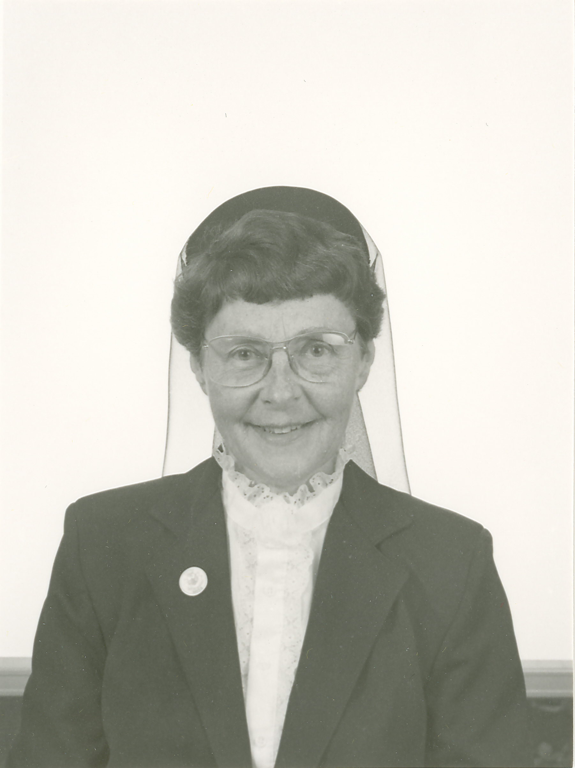

Sister Elena Dionne
(Sister St. Marguerite of the Redeemer)

September 21, 1923 - December 3, 2014

“My lover speaks; he says to me,
Arise, my beloved, my beautiful one,
and come!”
(Songs 2:10)

Sister Elena Dionne (in religion, Sr. St. Marguerite-du-Redempteur) responded to this invitation from the Lord on December 3, 2014 at the age of 91 years.

Her premature birth took place on September 21, 1923, and it was somewhat miraculous that this tiny infant who weighed barely one pound-and-a-half survived and thrived. She spent her first days of life nestled in a porcelain dish pan on the door of the oven in her family’s kitchen. She was baptized immediately at birth and taken to St. Bruno Church the following day to make her baptism official.

Her parents, were Edward and Margaret (Tardif) Dionne. Her father was born in Van Buren, Maine and her mother was born in Edmundston, New Brunswick, Canada. Her father was an insurance agent and her mother was a housewife. Elena was the fifth surviving child born in a family of five. Her size at birth earned her the endearing nickname of “Pee Wee” which followed her for her entire life. She had one brother, Bernard, and three sisters: Geraldine, Monica and Pauline (Harriet). Sister Elena is the last survivor of this generation of the Dionne family.

The Dionnes were fervent and active members of St. Bruno Parish of Van Buren, Maine. It was in this parish that Elena was baptized and made her First Holy Communion and Confirmation.

Some early childhood memories were provided by her older sisters on the occasion of her golden jubilee in Van Buren, Maine. Pauline’s earliest memory was when, at fours years old, her father brought Gerry, Monica and her to the Pelletier home telling them that they could play with their cousins there because the Indians had called ahead and said they were coming. It was a known fact in all the neighborhood that when the Indians came for visit they broke some person’s leg and left a baby as a gift--this time it was baby Elena.

Monica remembers the following: I went into the kitchen after the baby Elena was born and Grandma Dionne was in the process of taking her from her incubator to bathe her. A porcelain dishpan, padded with white cloth served both as incubator and bathtub. It was placed as close as was safe to the oven itself on the opened oven door. I watched and admired the Pee-Wee doll–the prettiest doll I had ever seen. Once while watching the bathing, Grandma removed her wedding ring and slipped it up on Elena’s arm. She then placed her in a dinner plate while she changed the swaddling clothes.

Her older sister Gerry recalls: When her Grandmother weighed the baby on the kitchen scale she used a meat platter as a tray. The result was that Elena weighed one-and-a-half pounds in the first week after she was born. Her brother Bernard recalls she weighed all of ten pounds on her first birthday. She caught every childhood disease common in those days and suffered all while gurgling. Now, he claims, she has more energy than any of the family, and she still goes through life with a smile.
Another recollection from her sister, Monica, follows: Elena was eleven or twelve years old when I was walking down the street and heard the sound of rapid little footsteps. Within seconds, my little sister flew by me, feet happily tapping to some tune in her head. She still moves quickly despite age and foot problems, and she sings joyfully in a strong mezzo soprano voice. She later became a member of the S.C.I.M. Community, an educator, musician and missionary. We are very proud of her!

Her teaching career spanned over a period of fifty-two years. She earned a Bachelor’s Degree in Education from St. Joseph College, North Windham, Maine followed by a Master’s Degree in Early Childhood Education from the University of Maine in Orono, Maine. As part of her Master’s Degree, she was privileged to travel to England to study the British System–“Schools Without Walls.” This was to prepare the staff to implement a similar system in M.S.A.D. #24 in Van Buren, Maine. She began her teaching career in Old Town, followed by Grand Isle, Caribou, Hamlin and Van Buren, Maine. She also taught in Methuen and Lawrence, Massachusetts. Some of her assignments included teaching music, singing and religious education.

Sister Elena studied with the Sherwood School of Music and obtained a license which allowed her to teach music all over the world. However, rather than pursue a career in music, she preferred to remain in education. Wherever she was assigned she also inherited the organist’s job at the parish church in addition to her teaching responsibilities.

In Sister Elena’s own words, she summarizes her very active, productive apostolic ministry: I am nourished by prayer and sustained by Community! One way I magnify the Lord is by showing my love for the people in Brazil. My love for the Lord and His people energize me to collect money for the needs of the Brazilian people. Sustained by my S.C.I.M. Community in this missionary effort and supported by the many generous donors who respond to my appeals, many children benefit from the money collected. Some of the renovations in Brazilian Schools follow: floors were leveled; ceilings were renovated; walls were painted and broken tiles were replaced. In the classrooms, new tables and chairs were provided. Two small rooms were added to the building for a CCD Office and an equipment area. Sinks were added to the exterior wall.

During her many years in Van Buren, Sister Elena visited many donors to collect funds for the Brazilian Mission. She also donated time during summer school vacations to volunteer in Brazil and Haiti. She knew no limits to her generosity to those in need in the world. She visited, cared for and taught the needy all of her years spent in Van Buren. She was especially gifted in her field of Special Education. She sought out the needy of her home town and did her best to care for their material and spiritual needs.

Sister Elena retired from full-time teaching at MSAD #24 in Van Buren, Maine, in 1993. At the time of her retirement Mr. Clayton Belanger, Elementary Supervising Principal, presented her with a very beautiful testimonial letter. He stated the following:
I remember seeing you over twenty years ago working in the small school. You had energy, purpose and a commitment to the students and to the school. For many of us, these goals dim with age, but I am glad to say to you that age has not affected your noble goals. I am sure you will keep these goals for the rest of your life. Keep it up, Sister Elena, and the rest of us will admire you and try to keep up with you.

In your long career in education, you have seen many changes in education along with trends of the day such as “whole word teaching” to “whole language teaching.” You have the ability to decipher the educational jargon and get to the essence of teaching the whole child.

With age comes experience and wisdom. In days of old, the elders would give the younger generation advice and counsel and many of us in education look to you for advice and counsel. Keep this God-given gift and use it often because education today needs all the help it can get.

When Sister Elena retired from full-time education, she was involved in Adult Education, remedial reading and private tutoring. She also volunteered at the nursing home in Van Buren where her father resided for a time. Later, when in the Saco area, she volunteered at St. Andre Health Care Facility where she brought Communion to the residents, wrote letters for them, and assisted them in any way she could.

In February, 2007, while residing at Bay View, a stroke limited her activities and occasioned a transfer to St. Joseph Pavilion. She recovered quite well from this incident, but her poor vision, enhanced by special equipment, still allowed her the pleasure of reading some choice books, another of her favorite activities.

Sister Elena remained active and interested in everything as long as humanly possible. Though her hearing and eyesight failed with the years, she did her best to remain abreast of current affairs and her devoted progeny who remained in touch with her. She dearly missed her closest sister, Pauline, who died on February 13, 2013, and who awaited her with the rest of the family in heaven.

Sister Elena answered the Beloved’s invitation to arise and come in her usual, energetic manner as in the words of the Song of Songs: “Be swift, my Lover, like a gazelle or a young stag on the mountains of spices.” (Songs 8:14)
On December 6, 2014, a Mass of Christian Burial was celebrated at St. Joseph Convent. The Most Reverend Robert Peter Deeley, Bishop of the Portland Diocese, officiated, assisted by Reverend Monsignor Andrew Dubois, Reverend Ron Labarre, homilist, and Reverend Hubert Paquet, retired chaplain.

The burial took place at St. Joseph Cemetery in Biddeford, Maine.

Sister Sharon Leavitt, S.C.I.M.

Feast of Epiphany, January 4, 2015

