BIOGRAPHICAL SKETCH

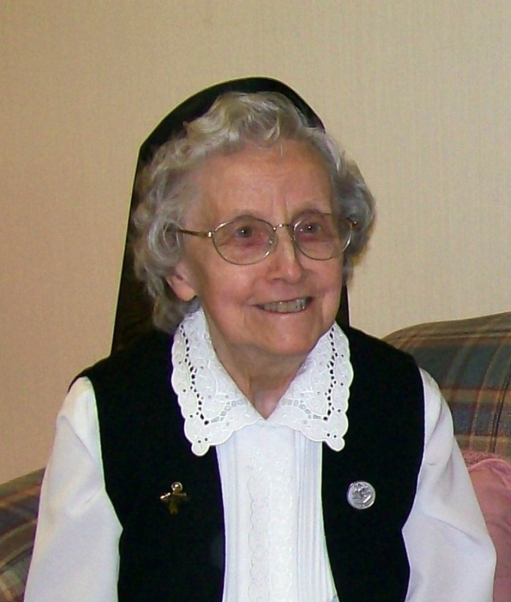

Sister Alice Beauchemin
(Sister Marie-Yvonne)

June 5, 1922 – March 13, 2017

“I am the way and the truth and the life.
No one comes to the Father except through me.”
(John 14:6)

Sister Alice Beauchemin (in religion, Sister Marie Yvonne) quietly and lovingly tiptoed to the Father who beckoned to His obedient daughter to come to Him in the last hour of March 13, 2017. Sister was a very quiet person. She was, however, a very interested, intent listener to the end of her days in our midst.

At one time, the superiors of the community asked each of us to write our autobiography. This request was taken very seriously by Sister Alice. So, in March 1979 she sat at the typewriter and submitted a very complete autobiography which I will now share with all of you who knew and loved Sister Alice. She was always quiet and rarely spoke about herself, but she left all of us the following detailed account of her childhood, family life and life as a religious.

I was born on June 5, 1922 in Central Falls, Rhode Island, the second child in a family of five—three boys and two girls. We moved to Pawtucket, Rhode Island into the house that was to become ours in later years when I was about five years old. I received my elementary education at St. Cecile, the parochial school which was staffed by the Sisters of Holy Union of Jesus and Mary. I attended St. John the Baptist High School also under the direction of the Sisters of Holy Union.

I had a very happy childhood where the days were filled with play, study and work. My father owned a small bakery in Central Falls, R.I. He was not a baker but he supervised the hired help, and also did the many odd jobs that were always abundant. He also delivered bread, pies and cakes to his customers. These were the years of the “Great Depression” and money was scarce. In order to keep the bakery open, my mother took on the added burden of full-time sales clerk and all around helper leaving the care of the children to my Grandmother Hetu who lived with us. Following in the footsteps of my older brother, Rene, I found myself working at the bakery on Saturdays and school vacations. This, I felt, was my contribution to the cost of tuition for my high school education.

I first thought of religious life during my early school years but did not give it serious thought until after high school graduation. I prayed for guidance and God spoke through events. Because of illness, my mother had to take time out from work at the bakery, so I offered to replace her at least for the summer. With fall and the beginning of school for my brothers and sister, I subconsciously made a plan with God asking Him to wait for me to enter the convent for three years, that is, until my sister, Yvonne, completed high school. She, then, could help while my two younger brothers were still in school. If God really wanted me to enter the convent, He would manifest His will in due time, I felt certain.

Many things happened during those three years. My father who had suffered from stomach ulcers most of his life, now contracted tuberculosis and had to be hospitalized. He died two years later in March 1944. While my father was in the hospital, mother and I worked full-time at the bakery with my older brother, Rene, who now married, was both baker and manager of the bakery. At this time when we depended on Rene for our family’s livelihood, he was called to serve in the U.S. Army, this being during World War II. My father was heartbroken when he heard the bakery had to be sold for mother and I could not manage it by ourselves. This left mother and I unemployed for the time being. My sister, Yvonne, graduated from high school that June and soon found employment with an insurance firm. I still thought of religious life, but with my father in the hospital and my two younger brothers still in school, I felt that God wanted me at home. After some time, I found work spinning wire in a cable factory; this lasted but a few months as I fell ill with double pneumonia and pleurisy which confined me to my bed for two whole months and for another two months I was unable to work. When I regained my health, I found temporary work in a plastic shop, then in a dressmaking firm and finally in a factory assembling Spiedel watch bands.

The call to religious life came again stronger than ever in the spring of 1947. Deep down I knew that this was the time to answer His call. My sister was working and my brother Rene had been discharged from the army and was with his wife and his son. Armand was home from the navy and only my brother, Wilfrid, was still in school. Mother was not too well and could not be left alone.

I prayed for light and guidance before consulting our parish priest, Rev. Joseph Lambert, who gave me a book listing the Religious Communities active in the United States. I read and reread the book several times. Teaching did not appeal to me so I eliminated the Sisters of the Holy Union, the only Community I really knew and admired. Finally, I narrowed my choice to three: The Sisters of Charity, the St. Vincent de Paul Sisters and the Servants of the Immaculate Heart of Mary. All three communities were involved in various apostolates including the care of young children. When I informed Father Lambert of my choices and requested his opinion, I learned that of these three communities, he had known the SCIMs as a youngster at Mt. Carmel School in Methuen, Massachusetts. He had also visited St. Anne Orphanage. Another factor that helped me in my decision was the fact that the SCIMs were under the patronage of our Blessed Mother.

My mother accepted my decision and the sacrifices that accompanied it for we had become very close since my father’s death. On July 4th, 1947, my mother, Armand, Wilfrid and I packed a lunch and drove to Biddeford, Maine where I met the newly appointed Mistress of Novices, Sister Jeanne d’Arc Duperry and her assistant, Sister St. Pierre-de-la-Croix (Sister Marguerite-Marie Auger.) At the end of my interview, I was accepted as a candidate and my name was placed on the list of incoming postulants.

At work the next day I notified my employer that July 31st would be my last day assembling watch bands. The remaining weeks at home passed quickly as mother and I shopped for a trunk, suitcase and “nun’s clothes.” On August 25, 1947 the family, including my Grandmother Hetu, drove to St. Joseph Convent, Biddeford, Maine. After donning the postulant dress, I rejoined my family out on the lawn until it was time to say goodbye for they had a long five hour drive back home. Within the next hour I was to meet my eleven companions from Maine and Massachusetts.

That first year was spent getting acquainted with the Sisters of the Good Shepherd, all of whom were strangers to me. I had no favorite teacher or friend to look up to for guidance or encouragement. Being rather shy, I felt this aloneness most on days of “grand congé” when novices and postulants were invited to mingle with the professed sisters. Perhaps because I was older than most of my companions, I readily accepted the structured life, the discipline, the silence, the hours of work and prayer.

To my surprise, I was initiated to the art of teaching for which I had no real attraction. But, so I thought, it was only for a year of teaching for half a day, the other half was spent at various tasks such as study, instruction, class preparation and one hour of sewing under the watchful eye of Sister St. Misael.

Soon it was summer again with the happy expectation of donning the novice habit. How I longed for that retreat which would end with the clothing ceremony to be held at St. Joseph Parish Church on August 13, 1948!

The novitiate days went by quickly as we delved into the study of the Gospel, the Constitutions and Rules and the Vows. What a joy to receive my letter of acceptance to become a professed member of the Servants of the Immaculate Heart of Mary (also known as Good Shepherd Sisters of Quebec). At last I would become a spouse of Christ! On August 15, 1949 with a limited number of parents and friends crowded into the chapel at 69 Adams Street, eight of the twelve who entered in 1947 pronounced vows for a year; but in my heart it was forever—with the grace of God.

I had mixed feelings upon receiving my first assignment: first grade teacher at St. Theresa School, Methuen, MA. How strange are God’s ways of calling each individual to a particular religious community! I had not considered entering the community of the Sisters of the Holy Union precisely because their only apostolate was teaching. What attracted me to the Servants of the Immaculate Heart of Mary was the care of orphans. Little did I know at the time that our main apostolate here in the United States was teaching. And teach I did!

Education became my field of action and study beginning with St. Anne Orphanage and Home, Methuen, MA, St. Joseph School in Biddeford, Holy Rosary School in Donelson, Tenn., St Joseph School in Old Town, ME and Grand Isle School in Grand Isle, ME. Except for my year at the Mother House, Quebec, from June 23, 1953 to August 17, 1954, which was a full and very enriching year spent at the Scholasticate, followed by two months of preparation for final vows on August 15, 1954, I spent 27 years teaching the primary grades, as principal for five years in Tennessee and three years at St. Theresa School in Methuen, MA.

My first years in teaching were difficult years. I lacked interest, experience, and techniques about how to manage fifty-five super active six year olds. Only God’s love and strength kept me going day after day as I prayed the saying on the wall: “God knows all, He can do all and He loves all”. (Dieu sait tout, Il peut tout et Il m’aime.) Since God wanted me to serve Him as a teacher, I decided that I was going to like it and took advantage of every opportunity afforded me in the field of education. After many years, the work load did not diminish but I was in a better position to cope with the situation.

My teaching experience in Grand Isle was unique in that we gradually changed from a traditional, structured teaching environment to that of the “open concept” where many learning and teaching activities are going on at the same time. The adaptation came slowly after many hours of courses, workshops, in-service sessions and much tension in applying the new ideas in the classroom.

It was in the spring of 1977 that I completed the required courses giving me the needed credits to renew my Maine teaching certificate, which would expire in July 1978. Surely this would be my last renewal. What would be my second career? Part-time teaching, tutoring, substitute teaching? All were possibilities, but I had six more years in which to search and inquire. However, God had other plans for me which He communicated to me through Sister Estelle Domingue, Provincial Assistant in April, 1977. Would I consider leaving the teaching apostolate at the end of the school year (not in six years) for a bookkeeping position at St. Andre Health Care Facility, our apostolate for the elderly. Since this seemed to be God’s Will for me at this particular time, I accepted in faith for I had a very meager background in bookkeeping. I was to have a year of learning experience and training under the expert supervision of Sister Therese Gagnon whom Reverend Mother Madeleine Beaulieu loaned to our Province for a period of two years.

Thus ended my teaching career. In the summer I moved to St. Joseph Convent in Biddeford, which was but five miles from St. Andre Health Care Facility where I would be traveling to work each day. In the fall of 1977, I registered for a course in accounting, one evening a week. A year passed and my teacher-supervisor, Sister Therese Gagnon, was recalled to Quebec to work in the accounting department at the Generalate.

I have found much happiness in my life. Looking back, I realize how often God manifested His will through events and I am confident He will continue to do so in the future. The future is His, mine is the present.

When Sister Alice celebrated her silver jubilee a Sister who had lived several years with her paid the following tribute to her: “Sister Alice generously served the Community as Superior, Principal and Teacher. She was very easy to live with, due to her perseverance, self-effacement and dedication. She never criticized nor gossiped. She preferred to go unnoticed, but her well-thought out contributions at meetings made everyone sit up and take notice. She is one of the few Sisters who will argue that she is bigger than she appears to be. Sister Alice is one you can count on to be a discreet listener, a generous and conscientious worker in everything that she undertakes. She values community togetherness, praying together, eating in the dining room together, and being present at all community meetings.”

Other qualities brought out in the sharing at the Prayer Service were: That she was a loving, quiet presence. She was a woman of character and determination. During the last years of her life, she spent many hours of quiet prayer and adoration in the main chapel before the Blessed Sacrament.

Sister was offered the Sacrament of the Sick several times during her many bouts of illness, but would respond, “It is not time.” When she accepted to receive this sacrament during her last week on earth, we knew and she knew that the time had come for the end of her earthly journey. Quietly and peacefully in the night, she simply stopped breathing and joined her Good Shepherd. Her last surviving brother, Wilfrid, his wife, Rita, and daughter visited Sister Alice during her final week on earth.

Her Mass of Christian Burial took place at St. Joseph Convent on March 17, 2017. Reverend Joseph Manship was the celebrant and homilist. Sister Alice’s brother, Wilfrid and his wife Rita and several nieces and nephews were in attendance.

Let me conclude this biographical sketch with sections of the homily given by Father Manship:

We have lost a woman who was sister not just to her family, friends and religious community but to all those to whom she ministered in her lifetime. She was one of those quiet, unassuming people often preferring to work in the background, yet when she spoke, people listened because she had something worthwhile to say.

In our thanksgiving is woven a deep gratitude to God for all Sister Alice has been to us. We are happy because we know that deep down her life was complete and that she was ready to go to God. An early Christian teacher once said: “The glory of God is someone made fully alive.” Although very quiet, Sister Alice was an intensely alive person, wonderfully whole and still insisting to nearly the end to share meals with the community in the main dining room.

There was something in her voice and demeanor when I anointed her that told me that she was gradually withdrawing from this life and finding her way home. She died with consciousness, readiness, peace, love and in God. But what was it that made it possible for her to withdraw from this life and conclude her journey in peace? It think we have a clue in the Gospel passage we just heard from John: “And if I go and prepare a place for you, I will come back again and take you to myself, so that where I am you also may be.” Jesus took us all to Himself when we were baptized. We were initiated into the community of the Godhead—the way of divine love and life. Because Jesus set us free by His death and resurrection, He made it possible for us to journey to the Father the same way He did. The way of Jesus, and now our way, is to live the kind of love that simply puts others before ourself. Sister Alice had put her unique gifts and talents at the service of the Lord and her Community. With faith, trust, perseverance, self-effacement and dedication she served with “spiritual docility” which I am certain came from her prayerfulness and commitment to Christ and her religious vows.

Go in peace, Good Sister. Live now in the joyful presence of the Almighty! Well done, good and faithful Servant!

Sister Alice was buried in St. Joseph Cemetery in Biddeford, Maine on March 17, 2017.

Sister Sharon Leavitt, S.C.I.M.
March 30, 2017

