BIOGRAPHICAL SKETCH

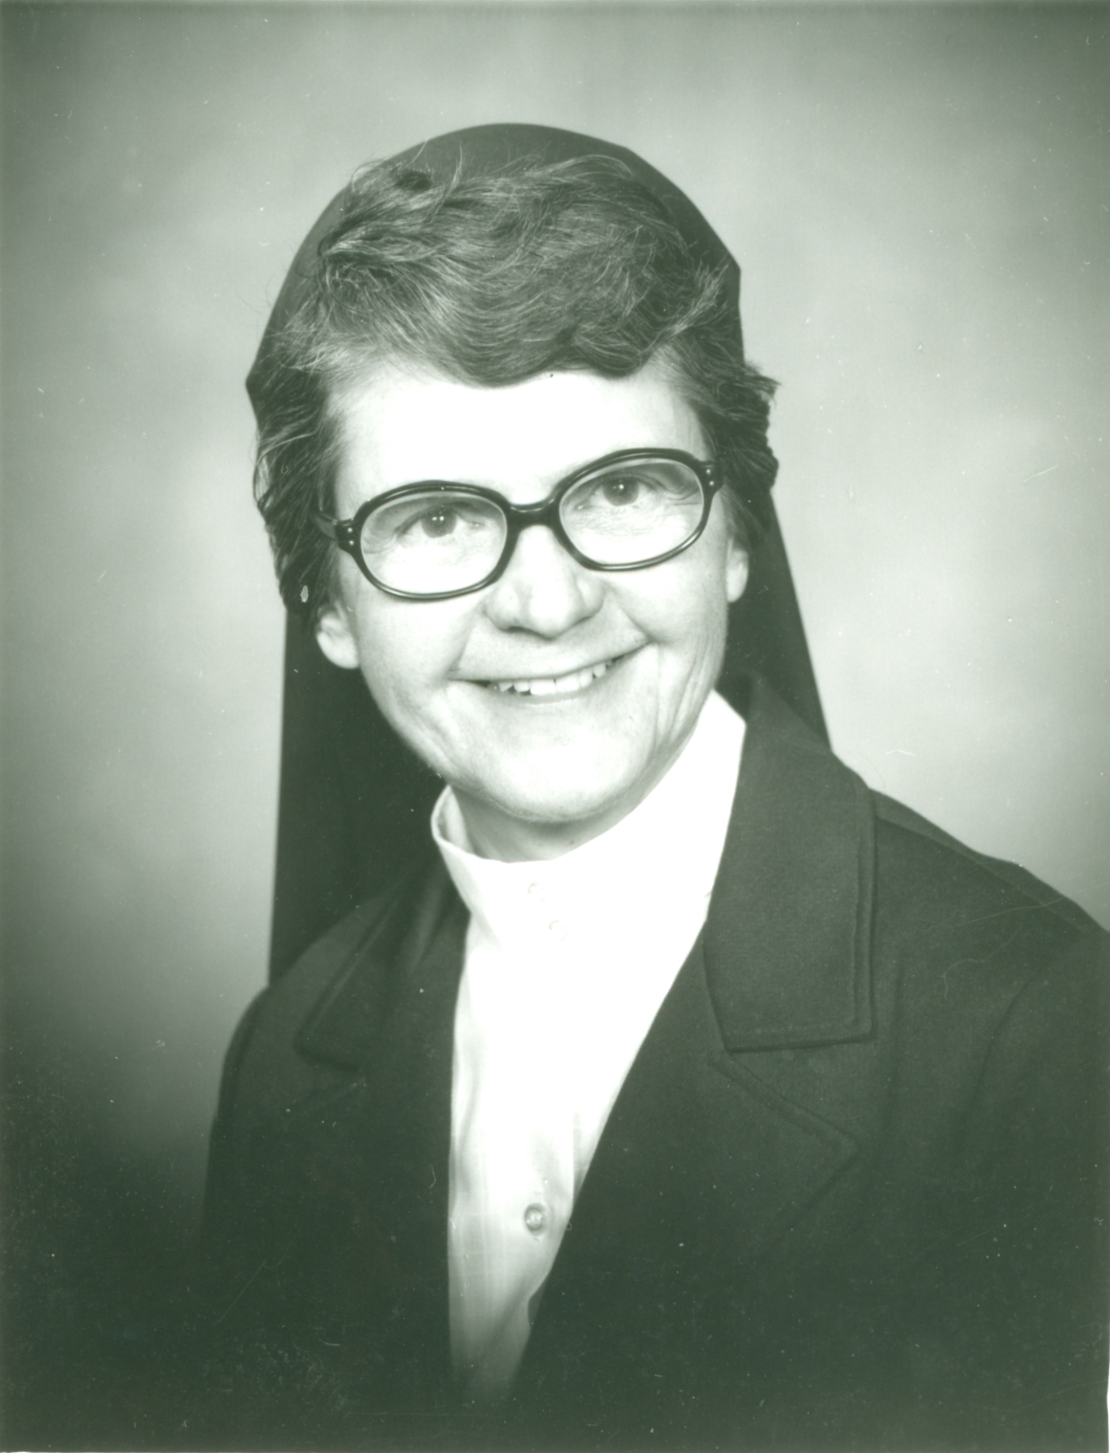

Sister Therese Pelletier
(Sister St. Therese of the Precious Blood)

April 21, 1926 - December 10, 2014

“After my death I will let fall
a shower of roses.
I will spend my heaven doing good on earth”
(The Story of a Soul)

Born of Eva Ouellette and Francis Xavier Pelletier, Therese Marie Pauline entered the world on April 21, 1926, the seventh of eleven children, six boys and five girls. She was baptized on the following day in St. Anne Church of Lawrence, Massachusetts by Reverend G.L. Aubun.

Her father, Francis Xavier Pelletier, was born in St. Germain, Kamaraska, Quebec, Canada on January 27, 1888 and emigrated to the United States when he was very young. He worked much of his married life as a mill worker. In the latter years of his life, he was employed as maintenance man for St. Theresa School and as sexton for St. Theresa Church, Methuen, MA. Her mother, Eva (Ouellette) Pelletier was born in Lawrence, MA in 1891.
They were united in marriage on September 8, 1913, at St. Anne Church, Lawrence, MA. Both were of a pious nature, and very diligent and talented in raising their family where the recitation of the rosary was a daily occurrence.

At the age five years, an automobile accident which occurred as she crossed Haverhill Street in Methuen, left little Therese with a broken leg and a fractured skull, causing her to be in a coma for the first three days of her long hospitalization. A possible recovery seemed of little hope at that time, and preparations for the wake were begun in the family home. Having been baptized “Therese” led her anguished mother to turn to her patron saint, known as the “Little Flower” to intercede for what would be believed as a miracle. Saint Therese responded to the faith that was calling for help and along with the care and affection of her brothers and sisters, Therese slowly recovered and returned home. Saint Therese of the Child Jesus became an important influence in Therese’s life in the future years.

Therese attended St. John the Baptist School (later to become known as St. Theresa School) in Methuen, MA. Though she may not remember too much of her earliest school years, the names of her teachers, the Good Shepherd Sisters, along with their influence, she never forgot. The home, where a great deal of affection may not have been expressed outwardly, nevertheless provided much security and closeness among the family members. The love that existed there was always deeply felt and experienced. The daily recitation of the rosary after the evening meal, united the family from an early stage. This took precedence over any other activity or commitment.

By the age of fourteen, Therese had developed a strong devotion to her patron saint and she began thinking of a Carmelite vocation. The simplicity and love the “Little Flower” had for the Lord, were qualities from which Therese gathered much strength. She delighted in reading and hearing of her life. About this time, her oldest sister entered the Good Shepherd Sisters as a postulant. Many family visits were later made to Biddeford to see Sister Bernadette, then known as Sister St. Claire of Jesus. Later, during Therese’s high school days, her sister, Claire, only eighteen months older than Therese, followed her older sister into the convent. Despite the fact that Therese greatly missed her older sister, she kept aspiring for the cloister. The two years that followed were years of searching and praying for God’s direction. Due to obstacles to her immediate entry into Carmel following high school graduation, and also because of her faith in the suggestion of the pastor of her parish that she might find satisfaction in following her two sisters into the Good Shepherd Congregation, Therese finally decided that this might be where God was directing her. So, on August 25, 1946, at the age of twenty, two years after her graduation from St. Theresa High School, Therese confidently made her way to Biddeford in the company of her parents to join her two older sisters as Good Shepherd Sisters.

Her First Profession was made in St. Joseph Church in Biddeford, ME on August 25, 1948. She took the name in religion of Sister St. Therese of the Precious Blood.

The many years that followed in teaching the elementary grades, be it in Biddeford, Methuen, Van Buren, Keegan and Lille, did not quite satisfy her aspirations. There were certain facets of teaching she could appreciate, of where her love for children dominated. However, because of a feeling of emptiness in this ministry came the temptation to question God’s will. She turned to God for strength and encouragement. She was then encouraged by a retreat director to make further attempts to enter the cloister. However, during this time of renewal that was taking place in many religious congregations, it did not allow for a transfer. Sister Therese left the apostolate of teaching after nineteen years of teaching in the elementary and junior high school level. She was then transferred to Old Town. After seeking counsel and direction, she was encouraged to train for Pastoral Care Ministry.

During these years in Old Town, Sister Therese taught in the Religious Education Program and also served as sacristan at the parish church and continued her ministry with the homebound and elderly people of the parish. At about this time, she received a call from the pastor of St. Mary Parish in Bangor, Father John Feeney, asking if she could be of help to them in their ministry at St. Joseph Hospital in Bangor. This came as quite a surprise to her as she did not know this priest. He knew of her visitations to the hospital and confidently appealed to her for help because the chaplain of the hospital had to absent himself due to illness. After an interview with Father Feeney at the rectory, she began her pastoral work, making frequent visits to the hospital assisting and comforting the sick and dying. This work was very gratifying to her and proved to be of considerable value to the patients she visited. She decided upon a suggestion of a counselor to pursue her interest in this field. An Orientation Course was soon to begin at the Bangor Theological Seminary in Clinical Pastoral Education. These three weeks of training were but a taste of what she was to pursue. In the summer of 1972, a twelve week training period was being given at the Andover-Newton Theological Seminary. Both growth and still more profound experience were waiting for her there. Following this program, Sister Therese met with the Director of the Hospital Chaplaincy Department of the Portland Diocese and was hired as an Associate Chaplain in the Augusta/Bangor hospitals and nursing homes under sponsorship of the Catholic Diocese of Portland.

The four years of Pastoral Care Ministry were both fulfilling and rewarding. Seeing Christ in the sick patients she visited daily, and taking the Lord to them in Holy Communion was both a joy and a reward. During this time, she resided with the Sisters of the Presentation of Mary for the first three years and then with the Sisters of Mercy for the fourth year. At the end of four years, poor health forced her to take some time off and return to Bay View. This was in the hope of returning after a year of rest to this ministry. God, however, had other plans for Sister Therese.

These plans included rendering service in the Pastoral Care Department at St. Andre Health Care Facility in Biddeford, then being reassigned to Old Town where she taught in the Religious Education Program while always continuing her ministry to the sick and elderly in their homes, in nursing homes and in hospitals. She continued this work when she was assigned to South Portland. It was during this time that Sister Theresa responded to the need for an archivist at the Diocesan Chancery in Portland and served in this capacity from 1991 to 2003. She was also asked to serve as a Regional Auditor for Annulments. Her training and experience in Pastoral Care proved to be of much assistance for this ministry and facilitated her approach to the clients who came to her for the interview.

In 1994 when she requested a thirty-day living experience in a cloistered contemplative community, the Sisters of the Visitation of Levis, Quebec were opened to her wish. There in the quiet and peaceful atmosphere of the monastery and its gardens, she spent much time in prayer, reflection and contemplation.

In 1997, Sr. Therese moved to Bay View due to the closing of convent in South Portland. It was in Bay View that she and Sr. Fernande Viel formed a “Lambs of Jesus” group that proved to be of spiritual benefit to the children who came to enjoy hearing about Jesus while trying to improve their relationship with Him.

After retiring from her position of Diocesan Archivist, at the age of 77, Sr. Theresa rendered clerical assistance to the Provincial Secretary and worked for the “Gift Shop” while still bringing the Eucharist to a local Nursing Home, to an Adult Day Care Center, and to local home-bound persons.

Sister Therese had a long, devoted life of self-forgetfulness and total giving of self. She quietly, lovingly gave to those most in need. Her serene, unassuming manner never called attention to herself. These gifts she used to bring the Good Shepherd to those suffering, lonely souls in need of loving care and attention.

She looked after her sister, Sister Claire, visiting with her daily. She also visited her sister, Mary Gaudette, in Methuen, MA until poor health made this trip impossible.

Sister lived a quiet, peaceful life and died as she lived–ready to meet her Beloved Good Shepherd on December 10, 2014 at the age of eighty-eight years.

Though Bishop Deely was unable to officiate at her burial service, due to a prior commitment, he did visit her wake on the eve of her Burial Mass.

A Mass of Christian Burial was celebrated at St. Joseph Convent on December 15, 2014 with Monsignor Andrew Dubois, representing the Bishop, as principal celebrant. Reverend Ron Labarre, homilist, and Hubert Paquet also assisted at the funeral Mass. The burial took place at St. Joseph Cemetery, Biddeford, Maine

Sister Sharon Leavitt, S.C.I.M.

Feast of the Baptism of Jesus
January 11, 2015

