BIOGRAPHICAL SKETCH

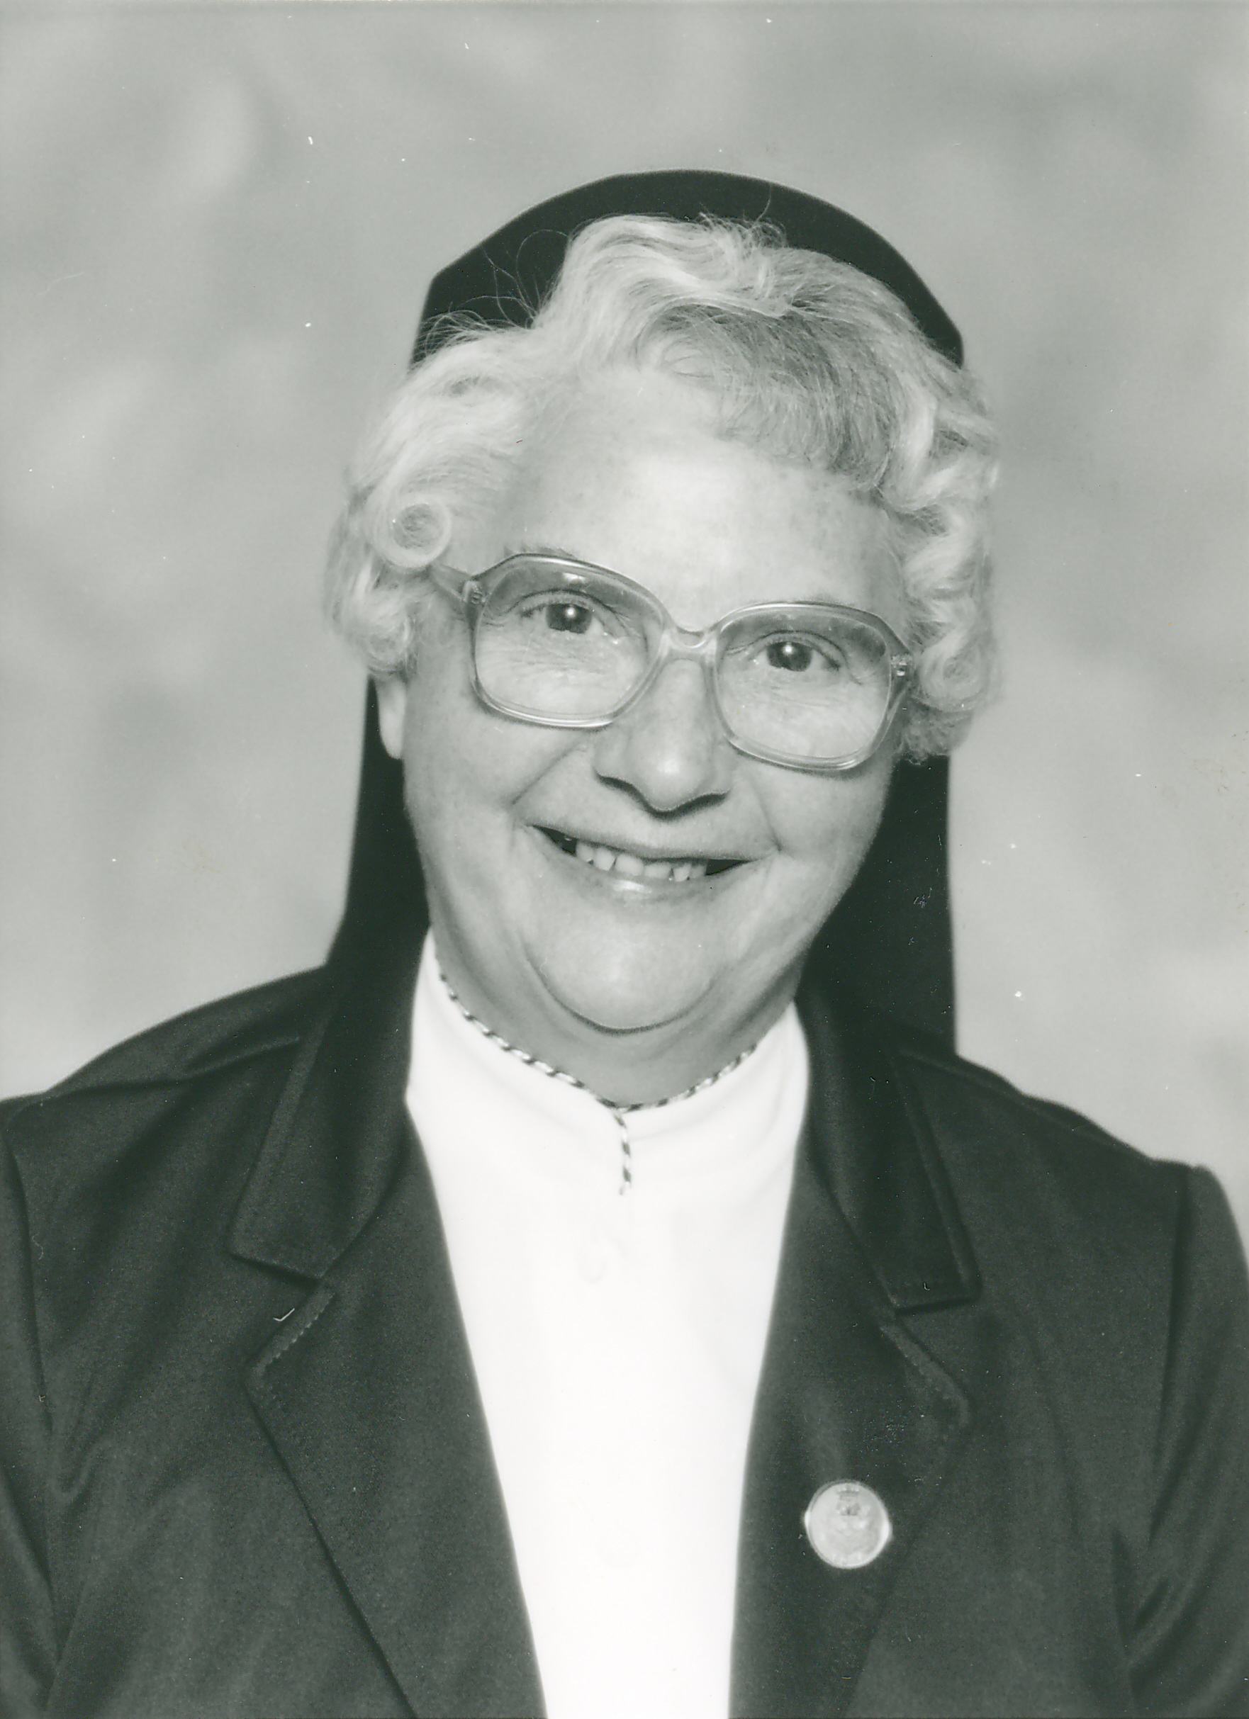

Sister Annette Bouchard
(Sister St. Audry)

July 29, 1918 - Novembre 30, 2015

“I have called you by name: you are mine;
because you are precious in my eyes
and glorious, and because
I love you.”
( Isaiah 43:1 and 4)

On November 30, 2015, Sister Annette Bouchard, in religion, Sister St. Audry, answered the call of her Beloved to come with Him to heaven. She had enjoyed her status as “senior Sister” of St. Joseph Province since 2013. Now was the time for her to leave all those she loved to join her family in heaven. As a very wise virgin, all was prepared in advance—her autobiography, which listed the prayer service and Mass readings she selected, as well her eulogy were all complete. Her 97 years had been fruitful years of loving and serving the Lord and all those whom she met. I will begin by giving her the opportunity to recount the interesting story of her life in her own words:

I, Annette Bouchard, was born on July 29, 1918 in Guerette, Maine, a parish of fifty families on the border of Canada. I was baptized on August 1st in Holy Family Church. My Godparents were Uncle Eugene Bouchard and Aunt Agnès Ouellette. I was the tenth child in a family of fifteen.

My parents, Charles Bouchard and Annie Marquis, had the greatest and best influence on my life. They had a strong faith and were very prayerful parents. During the holy seasons of Lent and Advent, the word “sacrifice” was often mentioned in our home. In October and May, a shrine to Mary was erected in our living room. Very often our neighbors would come to join our family to recite the rosary and sing hymns to Our Blessed Mother.

Concerning the deep faith of my parents, I recall an incident in my young life that exemplifies this devotion. At the age of six years, our family was living in Caribou, Maine and I had trouble with my eyes. Styes were breaking out continually on my eyelids and were obstructing my vision considerably. One Sunday, after Mass, my mother decided we would visit Father Chatagnon in the rectory to ask him to heal my eyes. He rubbed my eyelids with holy oil and my eyes were cured. Was it my mother’s faith that did it or the power of this saintly priest, or both? Our parents had such a great confidence in priests at that time.

I attended six different elementary schools in Maine in eight years: Guerette, Stockholm, Keegan, Caribou, North Caribou, and back again to Guerette. My dad was a hard working man but was one who couldn’t stay long in one place. Needless to say, that nomadic existence was a challenge to my scholarly achievements. Despite all the many moves, I managed to succeed in school and never had to repeat a grade. Also, because I was very sociable, I did enjoy meeting people and making new friends wherever we moved.

I recall when I was sixteen, my dad took sick one night. My mother was not at home at the time, for she had gone to Caribou where one of my older sisters was expecting her first child. I was alone at home with my youngest brother. We had no telephone to contact the doctor and the priest. I went to one of my uncles to use the telephone, running and praying, “Dear Lord, don’t let dad die! If you grant my request, I promise I will be a nun.” I really did not know what my promise was about since I had never been in contact with any nuns. My prayer was answered. After a week, my dad recuperated from his minor stroke and was able to continue working and supporting our family.

As for me, I started working as a maid for families in my town for two years. Then I went to Caribou where I was hired by a young Jewish family for the same type of work. That’s where and when the Lord sent me His messenger to remind me that I had promised Him something important.

Sister Rella Hebert, a neighbor came home from the convent after a year-and-half in the novitiate to take care of her sick mother. A few months later, Rella decided to re-enter the novitiate at 69 Adams Street in Biddeford, Maine. During her stay at home, Rella visited my mother and questioned her about my vocation plans. She wondered if I was interested in religious life. My mother replied, “I don’t know if she would like it, but I would be most grateful to God if He called one of my fifteen children to become His bride.”

That same week, I returned home for a vacation. On Sunday, a card party was held to help our small parish. It took place at Rella’s home. During the evening, Rella approached me and asked me if I would consider entering the convent. “Me? I don’t want to be a Sister!” Meanwhile, my mother had mentioned her previous conversation with Rella to Father Wilfred Soucy, our Pastor. After the card party, I was ready to return home with my parents by horse and sleigh when Father Soucy approached me and said, “I told your mother I would give you a ride home by car.” I agreed to his request. When he mentioned the word “convent,” I told him that I wanted to go home with dad! He said “No, no, I don’t want to force that upon you, but I really think that you have a religious vocation.” That night, I did not sleep; so, very early the next morning, I went to Alfreda’s home (another of my friends.) We spoke about entering religious life and within two weeks, we had come to a final decision. We were joining the Good Shepherd Sisters in Biddeford! Father Soucy was another important messenger from God in my religious vocation.

Without even writing a request asking to be accepted by the Provincial Superior, I left with Rella and my cousin, Alfreda Marquis, on January 22, 1938. On that Saturday, we spent the night in Lewiston, Maine. Since that was our last evening “in the world,” we decided to get the most out of it. We went to a dancing party followed by a treat at a restaurant.

What was to be expected of me in my new life? Everything was a mystery. “What do we do in a convent, I wondered?” I ventured to ask Rella. She told me that we teach and do all kinds of things. She added, “If you don’t like the work assigned to you, you ask for something else.” After two weeks of teaching, I decided to do just that. So, I knocked at Sr. Mary Leah’s door and said “Ma très chère Soeur, je suis tanné de faire l’école.” (“My very dear Sister, I’m sick of teaching school.”) Sister Mary Leah asked me, “Qu’aimeriez-vous faire, ma petite soeur?”(“What would you like to do, my little sister?”) I replied, “Je pense que je ne haïrais pas garder la porte.” ( I think that I wouldn’t mind answering the door”) It did not take long for me to realize that we do not choose our jobs in the convent, at least not in the 1930’s.

So, I continued teaching for twenty-two years at St. Anne School in Lawrence, Massachusetts and six years in North Caribou. This last assignment was sacred to me for it was there at this very spot that the Lord had cured my eyes through the ministry of the priest who had also baptized me. I renewed my gratitude to God every day I was stationed there.

Although I am very active and optimistic by nature, I encountered difficult times during my teaching career. At times, I felt inferior with only an eighth grade education and tended to do more manual work that helped me to feel more useful and important. But one day a Sister said to me, “Did you enter the convent just to wash floors?” After my first reaction of frustration, I said to myself, “I am here to serve others in whatever way I can.” Soon I regained my peace of soul. Many Sisters understood me and responded to my good will, thanks to the Good Lord!

After my many years of teaching, I was named house mother at St. Anne Orphanage , infirmarian at Bay View for ten years, treasurer in Biddeford, Coordinator at Rose Haven, Bay View, Superior in Grand Isle followed by many years of community services: housework, sacristan, in charge of maintenance at our cottages in Acton for six years, pioneer of St. Joseph Convent in Brookline, Massachusetts and at our Good Shepherd Pavilion at St. Joseph Convent in Biddeford. Here, I supervised the dining room, and also drove Sisters to doctor’s appointments.

God has gifted me with many talents and I use them to the best of my ability. It is always a great joy to give myself to others according to their needs. Maybe that is why a priest once said to a Sister of my local community, “When Sister Annette dies, I am going to make sure that she has a pail of water, soap and rags in her casket to keep heaven clean.” I replied, “It’s alright with me; God won’t mind as long as it is done through love and love alone!”

At one community meeting in Bay View, we were asked to write the good qualities we see in others. Following are some good points that were mentioned about me: attentive to the needs of others, kind, devoted, conscientious, good-humored, a community woman, expert in house-cleaning, unselfish, sensitive, prayerful, determined, sympathetic, a good listener, appreciative, joyful, and forgiving. I am not sure that all of these qualities are true, but don’t forget, I did not write them. True or not, they certainly helped build my self-confidence. I walked on clouds for a month after these testimonials and gave thanks to God for having given me so many beautiful gifts. I hope and pray that I may continue to glorify Him through them and use them to make my Sisters happy.

My favorite scripture passage is “Martha, Martha, you are worried and troubled over so many things, but just one is needed. Mary has chosen the right thing and it will not be taken from her.” (Luke 10:41-42.) In that prayerful silence, I hear the Divine Spouse ringing the golden bells, inviting me to come closer and closer to Him for the celebration of my golden jubilee in 1990. So, dear Lord, thank you for my religious vocation which is really a “Love at first sight story.” Now, I hope to hear you say, “Come, faithful servant and inherit the Kingdom I prepared for you.”

Sister Annette had a Spiritual Director, Christine Moroni, whom she trusted and admired greatly in her later years. Christine wrote a beautiful testimony to the memory of Sister Annette which follows:
We gather this day to celebrate a life, the presence of Sister Annette Bouchard, a woman of prayer, vision and healing. We gather to celebrate eternal life, the knowledge beyond all human understanding where Divine meets human and human meets Divine in Spirit and in Truth.

The events, history, and memories, our lives entwined with Sister Annette’s are what we celebrate today. We celebrate on two levels. First, the human reality of Sister Annette’s life and our encounters with her. Second, the divine challenge to see this witness and life-long community connection with the eyes of faith, hope and charity. Our encounters, stories and significant moments with her actually are parables.

Sister Annette’s life was and is a parable of faith. We may reflect on and speak about what a good religious she was, what she did for community, how she witnessed and gave of herself and her time to others. That is the human reality part of our reflection. It is like the scripture passage (Matt.11) that asks, “What did you go out in the wilderness to see? A reed shaken by the wind? (Sr. Annette doing her work?) Someone dressed in fine garments?” (Sr. Annette dressed in her religious habit?) BUT WHAT DID YOU GO OUT TO SEE? “A prophet? Yes, I tell you much more.” We encounter Sr. Annette as a sister in Christ, a prophet, if you will. This is the human encounter. But the phrase “and much more” refers to the Divine Encounter.

So we can go out to see the human reality of Sister Annette—a woman of faith, religious, industrious, with a great sense of humor, a helper in time of need and at any time. We can also go out to see and “much more”—the Divine Challenge. In other words, what is there for us “to see” in our knowing and living with Sr. Annette that goes beyond our human logic, beyond our rationale and beyond even canon law?

Perhaps Sister Annette’s life presents to us what we would dare not confront on our own. She claimed for herself the words of John 3:4-6, the story of Nicodemus. “I tell you, no one can enter the kingdom of God without being born of water and the Spirit.” Water and the Spirit—that is what we remember about Sr. Annette Bouchard. These show us through her example the divine challenge to be in relationship with ALL of the people we meet. We do not speak of perfection, but of God’s Desire in her attempts and desires to live this message of love in communion with the Body of Christ.

Her journey toward the Living/Loving God continued as she lived out her favorite scripture moving into eternity. (Is 43:1-2) “Do not fear for I have called you by name, you are mine. When you pass through the waters, I will be with you; in the rivers you shall not drown. When you walk through fire you shall not be burned and the flames shall not consume you.”)

God’s legacy also continues to bless her Community, family and all whom she has met in her life
(Is 44:3-4, “I will pour water on the thirsty land. I will pour my spirit upon your descendents and my blessing on your offspring. They shall spring up like willows by a flowing stream.”)

So now, in this time of ritual grieving, let us not only recall the life and sharings of the Sister Annette Bouchard who was, but rather relate to she who is with us now in love—kept so by our faith and hope of seeing her again. Kept so by the promise of resurrection of Jesus, the Lord! Alleluia!
So, dear Sister Annette, we are not celebrating goodbyes or farewells, but rather fidelity and faithfulness to a life-long commitment, as Mother Mary of the Sacred Heart, your S.C.I.M. Foundress, did, by giving fully of yourself for the salvation of souls and for the Glory of God. Amen.

On November 30, 2015, our dear Sister Annette joined her Beloved Spouse in heaven. Her Mass of Christian Burial was celebrated at St. Joseph Convent Chapel by Reverend Ron Labarre, our Chaplain, who also gave the homily. Many family members were in attendance and beautiful flowers adorned the chapel. In his homily, Father noted that Sister Annette was a very wise virgin who chose the prayer service to be used at her wake, the readings for the funeral service, the eulogist and even proof-read the eulogy (which was not to exceed three minutes).

Her eulogy was presented by her niece, Cheryl Bouchard Saenger, one of Sr. Annette’s many nieces. It was her late husband who had been selected by Sister Annette to compose and deliver the eulogy in 2002. However, the Lord called him home before the delivery, so his wife graciously replaced him.

Some of the points she shared about her Aunt are the following: Her love for her family was evident to each and every one of us; she wanted to be remembered by her family that she was a joyous person who was most happy in her religious life; she also prayed regularly for everyone in both her immediate and extended family; she loved caring for people—especially the sick; though she looked forward to her visits with her family in Augusta, Maine, and Northern Maine, her true home was right here in her Community; She truly lived out and believed that “It is more beautiful to give than to receive!”

Sister Annette was buried in St. Joseph Cemetery with family gathered to join in the final prayers as her body was laid to rest. May she rest in peace!

Sister Sharon Leavitt, S.C.I.M.

Third Sunday of Advent
December 15, 2015

