BIOGRAPHICAL SKETCH

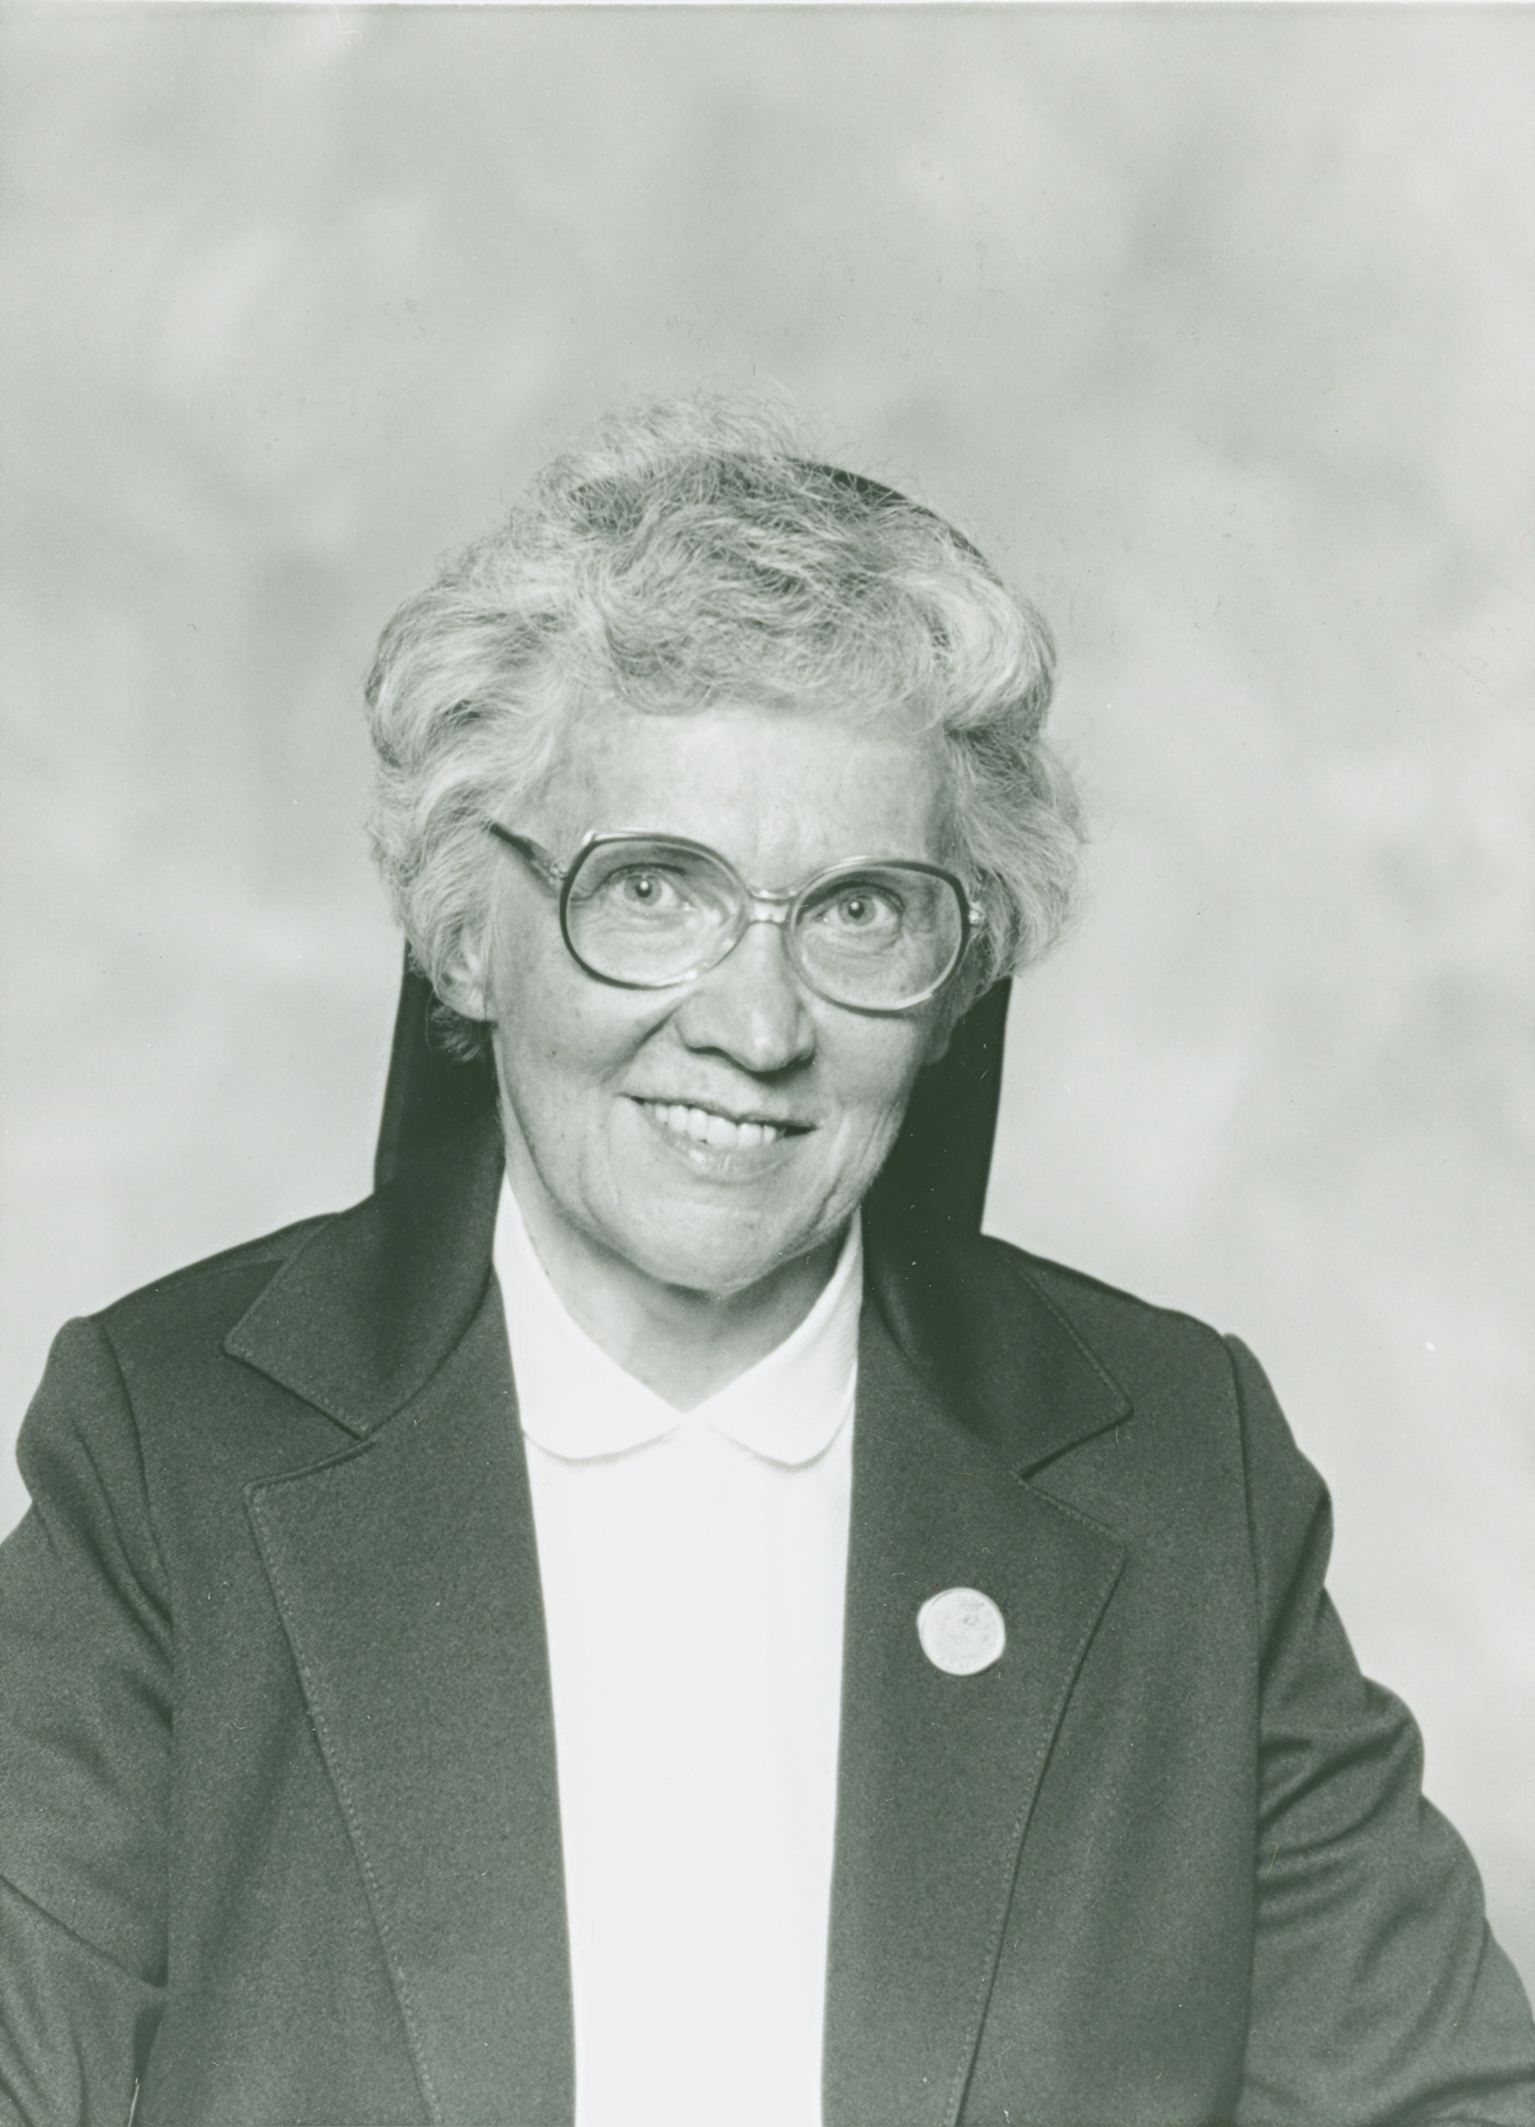

Sister Normande Fortin
(Sister St. Léona)

November 13, 1929 - August 7, 2016

“Whoever follows me will not walk in darkness,
but will have the light of life,
says the Lord.”
(John 8:12)

On August 7, 2016, the day following the Church’s celebration of the Transfiguration of Jesus, Sister Norma Fortin beheld the “Transfigured Face” of the Lord in Heaven. Her journey home was long and undoubtedly painful as this very talented soul saw her many gifts return to the Lord—her vision, her hearing, her mobility, her independence. Yet, she never complained and always had a ready smile when able to respond.

During Sister Norma’s several years of silence and union with the Lord, her brother Robert and his wife, Joanne, traveled from Winslow and visited with her each week. They would simply sit quietly at her side in prayer. She knew that they were present, but could only rarely acknowledge their presence.

Sister Norma loved beauty and nature. She saw the hand of God in all of creation. The ocean, the shells on the beach, the Lady Slipper growing amidst the pines near the road, all was beauty and art to her delicate loving nature. She created table center pieces, door hangings, gifts to be sold and treasured, never repeating the same beauty twice. She would “add character” to her creations and enjoyed sharing them with others.

During her later years while at Bay View, she befriended guests and made a lasting impression on those she reached out to help. She often became a “spiritual mother” to them, listening attentively and offering sound spiritual help.

In June 2003, Sister Norma celebrated her “Golden Jubilee” of vows at our Bay View Convent. Prior to this celebration, she shared her life story which follows:

What an eventful day in the Fortin household November 13, 1929 was! The third set of twins made their appearance in the home that day. A little boy, baptized Normand and a tiny little girl baptized Normande. Each weighed about three pounds and had to be kept warm near the open oven of the kitchen stove. Despite their fragility, they were bundled up and rushed to the local church, St. John the Baptist in Winslow, ME to be baptized on the very day of their birth.

Two other sets of twins had died at birth, so this very religious couple took no chances in delaying the baptism of these treasured, fragile babies. Sister Normande’s twin brother died at seven-and-a-half months. Normande was the survivor and was chosen by the Good Shepherd for our Community.

The Fortin family raised cattle and her father and brothers ran a slaughtering business. A great deal of love surrounded the two daughters and eight sons of Alphonse and Julia Fortin. All were hard-working people who had a great faith and trust in the Lord. They had fifteen children and only ten lived to adulthood. Grief and multiple losses were part of their daily lives. The God of Love sustained them always.

What a joy it was for her mother to receive bouquets of dandelions (God’s gold) from the generous little hands of Normande who loved these golden treasures growing in the fields surrounding her home.

Normande grew up with eight older brothers. Their friends often visited the Fortins to play with them. They used little Normande as their “water girl” as they played baseball and other sports. Normande began serving others at a very young age. At times she would seek out girls when she was over-saturated by all these boys. She would then visit her aunt who lived nearby and who had five girls for Normande to play with.

Little Normande had a thirst for knowledge from a very young age. She attended St. John School in Winslow (staffed by the Ursuline Sisters) from first to fourth grade. When in school, there were several boys named Normand, so Normande decided that she would prefer to be called Norma. From grade five to her high school graduation, she attended Winslow Public Schools. She graduated from Winslow High School in the class of 1949. In grade five, Norma had a teacher, Miss Mildred Marcia, who developed in her a great love for poetry and literature. Norma began to be a regular visitor to the Winslow Library to satisfy her thirst for good literature.

The call of the Shepherd was heard by Norma in her senior year of high school. She visited the Augusta Retreat house and met Father Fernand Rivard, O.M.I. Later, Father was invited to the Fortin home for a meal. Norma inquired again about religious communities of Maine. She had an aunt in the Holy Family Sisters and would have liked to visit her to discuss religious life, but this never happened. Norma took this as a sign that the Lord did not want her to enter that community. Father Rivard told her of the St. Joseph Sisters and also of his aunts in the Servants of the Immaculate Heart of Mary, also known as the Good Shepherd Sisters of Quebec. The voice of the Shepherd had again been heard.

In 1950, while Norma was employed at Montgomery and Wards, she decided to return to Augusta to make a retreat and discern her vocation. This was a fruitful experience for this young lady. The Oblate Fathers recognized her good will and zeal and gave her a “vocation test.” She was asked to recruit retreatants for their retreat center in Augusta. Norma gladly accepted this challenge. She and a friend walked the streets of Waterville and Winslow after their day of work and succeeded in recruiting fifteen people for the upcoming Oblate retreat. Norma passed the test with flying colors!

The Good Shepherd was still beckoning Norma. She visited Bay View and met Sisters Lillian Bonin, Marguerite-Marie Auger and Alice Labarre. She was also introduced to a sister who was in formation, Sister Jeannette Labrecque. Norma was very favorably impressed by this visit and the people she met there. The great variety of apostolates also appealed to her.

The seed had been planted in this young woman’s heart back in second grade when she promised Jesus to be “his” one day.

She continued to work at Montgomery and Wards for another year. She informed her boyfriend of her intention to enter the convent at this time. She also began preparations for her entry to the Bay View Novitiate in September. She was a daily communicant and one day after Mass, her Aunt told her of another young lady named Marie Roy who was also interested in religious life. Norma advised Marie to visit Bay View Convent and showed her the trousseau she had prepared. Marie had only a couple of weeks to prepare, but she got to Bay View on time in September, 1951.

When the two years of initial formation were completed, Sister Norma was assigned to teach forty-nine sub-primary students at St. Joseph School, Biddeford, Maine. This was quite a challenge! Sister Norma taught young students from 1953 to 1957.

In 1957 came another adventure into the unknown. This involved boarding the train for Quebec City. Here Sister Norma worked in the printing room of “Le Petit Courier.” This was a completely new experience for her, needless to say. How good it was to return to the United States after this year!

From 1958 to 1969, Sister Norma taught in the primary grades of the parochial schools. The call to teach little ones of the Love of God was again heard as she transferred to St. John the Evangelist School in South Portland in 1968 to 1971. She also answered the call to teach religion at St. Edward Convent in Bar Harbor in 1971-72.

In 1973-74, Sister Norma took a year of Clinical Pastoral Education at Maine Medical Center in Portland, Maine. This course led to ministry at Elizabeth Seton and Thayer Hospitals in Waterville, Maine from 1974-76. Sister boarded with the Sisters of St. Joseph in Winslow while she ministered to the sick and dying.

A highlight of Sister Norma’s spiritual life came in 1976 when she attended the Eucharistic Congress in Philadelphia. In her own words, she stated: “The whole week was a pilgrimage! We were very busy attending conferences all week long. The Eucharistic Congress has given me a legacy of deeper faith, peace and greater detachment and love of God. I feel that I must ever-radiate His Presence to others, and to be one in Him—the Bread of Life!”

In 1976 to 1979, Sister Norma accepted the challenge of establishing a learning center at St. Joseph School, Biddeford. Here she again shared her artistic talent and enthusiasm with youngsters in the primary grades. She also became the librarian where she helped and encouraged the children to read and love books.

Nextcame the call to help the learning disabled at Mt. Carmel School in Methuen, Massachusetts from 1979 to 1982. She also became the librarian where she shared her love for literature and reading with the children.

In the late 1970s a congenital eye condition was diagnosed when she had a terrible fall down the cellar stairs while on a family visit to one of her brothers in Winslow. Upon examination by an ophthalmologist, Retinitis Pigmentosa was diagnosed. This condition, along with Macular Degeneration began to slowly cause her to have very impaired vision. Unfortunately, neither of these conditions could be cured. However, Sister Norma did not let this diagnosis cause her to give up. She continued to serve and share her many God-given talents with others—wherever she was asked to serve.

In 1982, she journeyed north to Van Buren where she was asked to be a teacher assistant to Sister Eva Chouinard in the French Lab at Van Buren District Secondary School. This assignment was followed by a return to Bay View from 1983 to 1985. Sister Norma could always be counted on to enhance the dining room tables with lovely centerpieces.

During the years 1985-89 Sister was called upon to do Pastoral Ministry in St. Theresa Parish, Methuen, Massachusetts and in St. John Evangelist Parish, South Portland.

Another new challenge and need she met was in the Host Department of Bay View from 1990 to 1999. She was also actively involved in the Gift Shop and was always ready to lend a hand wherever her many gifts and talents could be of service.

The Lord blessed Sister Norma with many valuable gifts of creativity, love of life, intelligence, curiosity and laughter which she generously shared with God’s children, the hospitalized and the home bound. As the Lord allowed her gradually diminishing vision and hearing to continue, her faith and courage continued to bring her ever-closer to the Good Shepherd who had called her and sustained her in our S.C.I.M. Community.

Sister Norma attended a course for the visually impaired and continued to be an avid reader with the assistance of “talking books” from the Maine State Library. Her indomitable spirit continued on as she bravely ventured forward into the unknown. She journeyed into the arms of her loving Good Shepherd deeper and deeper into the valley of darkness and silence.

In 2004, a stroke necessitated that Sister Norma be transferred to Good Shepherd Pavilion. She adjusted well to her new environment and participated in many of the activities available. She was grateful for having more time to pray and socialize at recreation. Her brother, Robert and his wife, Joanne were faithful to visit her from Winslow. She always kept abreast with current events and was faithful to keeping abreast of the national news.

Sister Norma continued to ambulate with her walker as long as was humanly possible. Around the year 2011, she was no longer able to ambulate. In her geriatric chair, she continued to attend as many group gatherings and activities as she possibly could.

For the last couple of years of her life on earth, Sister Norma rested peacefully in the arms of Lord awaking only occasionally for nutrition. If anyone had a special need or intention, Sister Norma was a powerful intercessor on high to have them granted. It was a mystery to others how thin the thread attaching her to this earth was becoming, yet she lived on.

On the Feast of the Transfiguration of the Lord, Sister Norma received the Sacrament of the Sick and early morning of the following day her frail being was peacefully taken into the arms of the awaiting Good Shepherd. Her brother and sister-in-law spent the last afternoon of her life at her bedside.

Many friends and family attended her Prayer Service. Her burial service was very well attended by her faithful brother, Robert and his wife, Joanne, along with many of her friends and relatives.
Sister Norma’s Mass of Christian Burial was celebrated at St. Joseph Convent on August 10, 2016 with Reverend Ron Labarre as celebrant and homilist. The burial took place at St. Joseph Cemetery, Biddeford, Maine.

A beautiful eulogy was delivered by Sister Madeleine D’Anjou, a member of Sister Norma’s group. Part of her eulogy follows:

Sister Norma welcomed both pain and pleasure in her life and she got to know her true self. Like the twisted and stunted trees, the partially dead ones with tortured limbs, she reached longevity through adversity. Trees, like we human being, breathe, drink, generate, face tragedies and losses, and their personal history is written in the width and number of their rings. They do not, as the scientists had hoped, have a DNA, nor do their cells contain the elixir of life to gift us with longevity. Rather, they teach us “we should not allow adversity to stand in our way, but should instead, turn it to our advantage.”

Norma loved nature—trees, flowers and insects alike and treated all of God’s creation with respect. She learned from them and it made it possible for her to transcend her trials and to see the hand of a Loving God molding her into the daughter He created her to be. She achieved a spiritual life that we can all aspire to. It is fitting that we should dry our tears now and bid her “Au revoir,” until we meet again. Sister Norma has run the race and won the prize. For her life, example and intercessory prayers, we sing hymns of praise and thanksgiving!

Sister Sharon Leavitt, S.C.I.M.

Feast of the Passion of St. John the Baptist
August 29, 2016

