BIOGRAPHICAL SKETCH

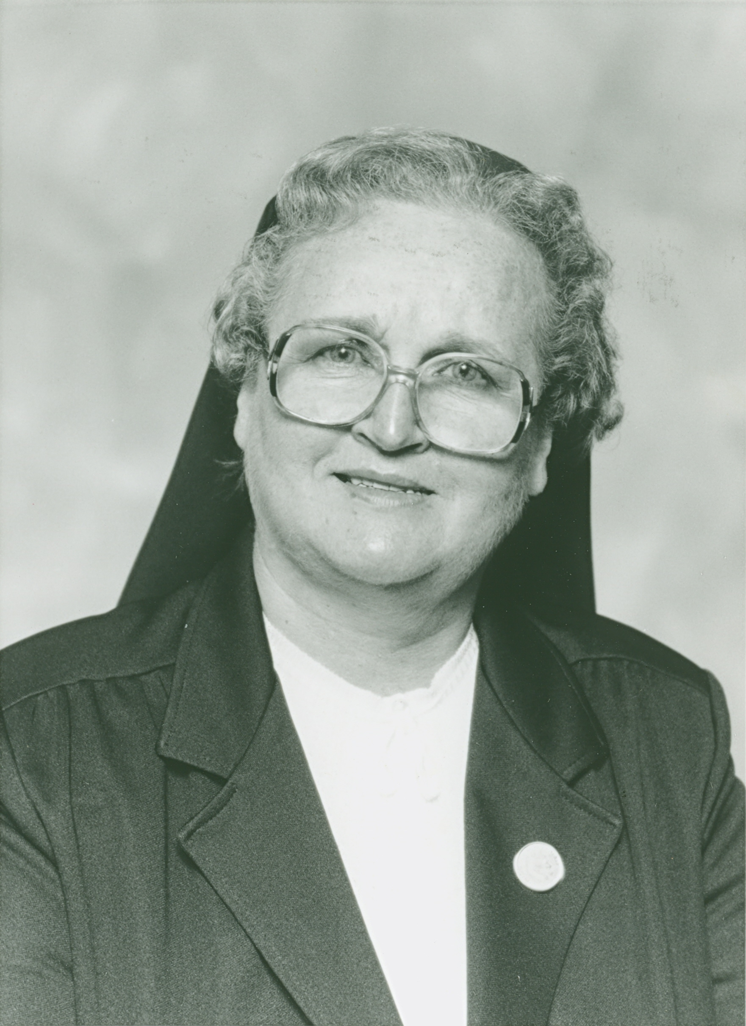

Sister Theresa Lanouette
(Sister St. Lucille of Jesus)

February 04, 1926 - August 23, 2015

“I will thank you always for what you have done,
and proclaim the goodness of your name
before your faithful ones.”
(Psalm 52:11)

Sister Theresa Lanouette, formerly known in religious life as Sister St. Lucille of Jesus, completed her final pilgrimage to the Lord on August 23, 2015, at the age of 89 years.

Theresa was born in Lawrence, Massachusetts on February 4, 1926. She was the tenth child in a family of fourteen children born to Joseph Lanouette and Alice Michaud. There were four boys and ten girls in the family. Theresa attended St. Anne Elementary and St. Joseph High School (later known as St. Anne High) in Lawrence, Massachusetts.

Her father was a laborer in the Lawrence Brewery. He was a devout Catholic and on his way from work he always stopped at church to make the stations of the cross and say his night prayer before returning home to his big family. He was a family man and loved all of the extended family. Annually he would organize a Lanouette Family Reunion. He organized games and many enjoyable activities for all the family. He continued this tradition as long as his health permitted.

Their home was located close to the convent of the Good Shepherd Sisters and the Marist Brothers in Lawrence. Theresa shared that she always loved and admired the Good Shepherd Sisters who taught her in elementary school. She joined their ranks in 1945. How pleased and proud were her parents and siblings to have one of the family become a nun!

Theresa shared that she always loved school and learning. She earned her Bachelor of Arts from St. Joseph College in Windham, Maine and her Master of Arts from Salem State College in Massachusetts. She taught in parochial schools of Biddeford and Old Town in Maine, in Lawrence and Methuen in Massachusetts, and also in Donaldson, Tennessee. She also taught in the public schools of Van Buren, Maine. For many years, she taught Junior High School students who were slow learners. She taught Special Education Classes in Lawrence and in Methuen, Massachusetts. When, for health reasons, she retired from teaching adolescents for 35 years, she was transferred to Lawrence, Massachusetts where she began teaching Adult Education night classes to immigrants in the Lawrence, Massachusetts area. She learned Spanish in order to be of more help to those of Hispanic background. She continued in this ministry for twenty years. The Hispanics who were her students were very proud and happy to have a religious teacher who spoke their language. They said that they couldn’t afford to attend the Catholic school in their country of birth.

The quote on the Mausoleum of Mother Mary of the Sacred Heart applies to the life of Sister Theresa also: “She loved the poor, helped the needy and taught little ones the ways of God.”

Theresa always loved and wanted to help the elderly in whatever area she lived. In her free time, she found those in need and reached out to them. She would cook, clean, shop, and do her best to meet their needs.

Theresa was plagued with poor health for many years. She bore this cross patiently and never complained of her ailments. She was a courageous and brave woman who was always most grateful for any service or favor given her.

She had a fervent Marian Devotion all her life. She was a very active member of a prayer group in Methuen, Massachusetts led by Father Mead, S.M. She joined pilgrimages to “Notre Dame du Cap” and “St. Anne du Beaupre” in Canada and even went on a pilgrimage to Our Lady of Knock Shrine in Ireland with her prayer group. She was a devout member of the Charismatic Prayer Group in Biddeford, Maine, for as long as her failing health permitted. She was very active in the “Marian Movement for Priests” which was organized in Biddeford some 20 years ago. She made hundreds of rosaries for the missions and continued to spread her great love and devotion to Our Lady. In 1994-95, she was very grateful to attend “l’Année Doctrinale” in Quebec.

Sister Theresa, because of her failing health, was transferred to St. Joseph Convent in 1995 where she served the community as sacristan, receptionist, and driver. She also accompanied many Sisters on their final journey to heaven.

Several members of the Lanouette family attended Sister Theresa’s prayer service and shared on her active participation and interest in their lives. Her two younger sisters, Pauline and Doris were able to attend and spoke lovingly of Theresa as did several nieces, nephews and grandnieces. Her surviving brother, Roland, was able to attend her funeral mass. Gordon Armstrong, a former employee, was also in attendance. His daughter when she was young ran a lemonade stand in Old Orchard Beach with another little girl and their earnings were given to Sister to help defray the postage when she sent her rosaries to the missions in Brazil. Several members of our Affiliate group were also in attendance. Sister attended their meetings as long as she was able. She had a great devotion to the Chaplet of Mercy and faithfully followed the programs of the Catholic television channel Eternal Word Television Network.

A Mass of Christian Burial was celebrated at St. Joseph Convent on August 26. Father Ron Labarre, our Chaplain officiated. In his homily he spoke of Sister Theresa’s “gracious gratitude.” At the Prayers of the Faithful, he was always touched by her expression of gratitude to the priest who celebrated the liturgy for us. Her life, he shared, was a life of gratitude and thanksgiving and a great gift to the Lord of Life. She was “One in love with the heart of God.”

Her niece, Karen Smith, shared a eulogy on her Aunt Theresa. Excerpts follow:

Aunt Theresa was known as the “tomboy” of all the girls. Our Aunt loved softball and was a great pitcher when she was young. When the nieces and nephews came to visit her in Bay View, she would always organize a softball game.

It was a surprise to her family that she entered the convent. She wasn’t the quietest of the girls and always liked to find a reason to argue with her sister Evelyn, according to my mother.

One of the first memories my cousins and I have is visiting my Aunt at St. Anne Convent in Lawrence, Massachusetts. I remember being escorted to the parlor where there was a bank in the shape of a little African boy with his hands out. When you put money in the slot, he would move his head up and down numerous times as if to say “thank you.”

Aunt Theresa, no matter what was going on, always found time for her family. She took a sabbatical year so she could help take care of our “Mémère. Aunt Theresa was always there to give us advice whether we wanted it or not. She never held back any punches. With Aunt Theresa, her advice was surrounded with the presence of God which was always her way and should be.

Aunt Theresa was constantly praying for her family and her community. It was nice to know that you had someone on your side. We never underestimated the power of prayer. So, I just want to say to God, “You made my Aunt the way she was and is. You have your work cut out for you and heaven will be organized in no time now that she is there with you.” Aunt Theresa, we will miss your words of wisdom, your kindness and your loving presence.

Sister Theresa was buried at St. Joseph Cemetery in Biddeford, Maine. Her brother and two living sisters, several nieces and nephews and Sisters were present at Sister Theresa’s final prayer service.

TRAHE NOS VIRGO IMMACULATA

MOTTO OF OUR S.C.I.M. CONGREGATION

Sister Sharon Leavitt, S.C.I.M.

Feast of the Nativity of the Blessed Virgin
September 8, 2015

