BIOGRAPHICAL SKETCH

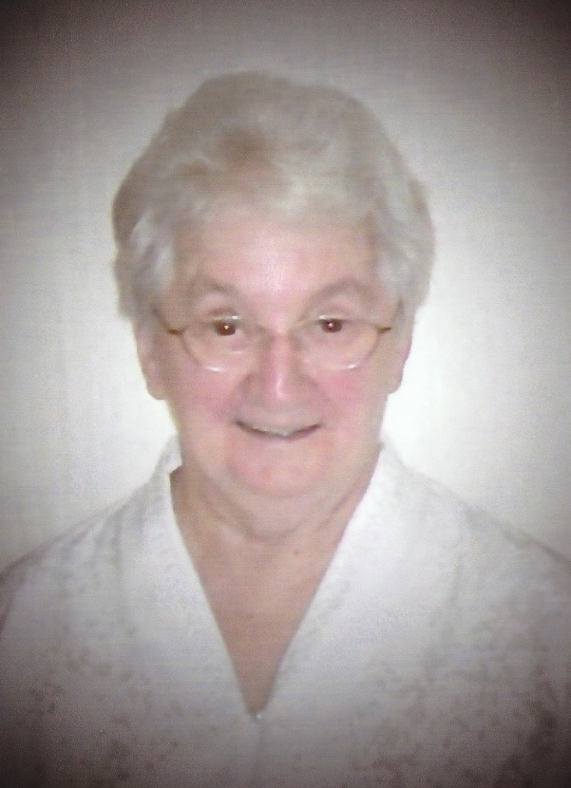

Sister Viola Lausier
(Sr. St. Benedicta)

July 21, 1924 – July 9, 2023

1820th death
"The Lord is my shepherd; I shall not want.
He guides me in right paths.
I fear no evil; for you are at my side
with your rod and your staff that give me courage." (Psalm 23)

On Sunday, July 9, 2023, Sister Viola Lausier, whose name taken at her first profession was Sister St. Benedicta, completed her life’s journey and was welcomed to her eternal reward by the Good Shepherd whom she had followed faithfully for 82 years of her religious life. Sister Viola was born in Grand Isle, Maine on July 21, 1924. She was the second child in a family of sixteen children born to Thaddie Lausier and Mabel Michaud Lausier. Sister Viola attended Lincoln School from kindergarten to her sophomore year. She later completed her high school education through the American Correspondence School.
Sister Viola shared that she had a happy family life in a close-knit loving, Christian family. They were active parishioners of St. Gerard Parish in Grand Isle. Her father was employed by the Bangor-Aroostook Railroad. He sang in the Church choir. He would sing to the babies as he rocked them to sleep. Her mother was an excellent seamstress, making her children's clothes. Before entering the convent, Viola earned enough money picking potatoes to buy her mother an electric sewing machine.
Two of her father's sisters were members of the Daughters of Wisdom Community and her uncle was a member of the Montfort Fathers. However, Sister Viola shared that her desire was to serve women in prison and children in orphanages. This is what led her in August of 1940 at the age of sixteen to enter religious life with the Servants of the Immaculate Heart of Mary, also known as the Good Shepherd Sisters of Quebec.
Sister Viola completed her two years of formation with the Good Shepherd Sisters in Biddeford, Maine. Then she spent one year at the Good Shepherd Scholasticate in Quebec. She later earned a Bachelor of Arts Degree from Dominican College in Racine, Wisconsin. She also took extensive courses in Finance and Management at Notre Dame University in Indiana, and studied at Anna Maria College in Worcester, Massachusetts as she worked toward an MBA degree.
Sr. Viola always wanted to work with children, and she did so as she began her ministry in religious life as an educator tirelessly dedicating herself to teaching children in grades 3 through 8 in Methuen and Lawrence, Massachusetts, as well as in Caribou, Maine. For several years she also served as principal at St. Theresa School in Methuen. She was active in the field of education for fifteen years. From there Sr. Viola went on to serve as a finance professional at St. Ann’s Home, Inc. in Methuen, Massachusetts and later at St. Andre Home, Inc. in Biddeford, Maine. Marked by our charism, Sr. Viola gave an SCIM color to her ministry as she advocated successfully with State government in Massachusetts and in Maine to secure needed financial assistance for children and for women served by St. Ann’s Home and St. Andre Home.
Sister Viola’s work at St. Ann’s Home and at St. Andre Home as Finance Director made an impact in the Archdiocese of Boston and the Diocese of Maine and were greatly appreciated and recognized by both Church and State leaders. While providing uncompromising financial discipline and oversight, she was always a staunch advocate for the children and women served by St. Ann’s Home and St. Andre Home.
Sister Viola had many God-given talents and a very special aptitude for communicating love, goodness, and mercy on behalf of persons in distress—especially to the little ones. Those who worked with Sister Viola at St. Andre’s felt that she embodied the soul of St. Andre Homes. She became a living incarnation of the ideal, the mission and the charism of our beloved Foundress, Marie Fitzbach Roy. Like her, Sister Viola was a woman dedicated in a particular way to the ministry of mercy, drawing from the Heart of Jesus that goodness of soul and that tenderness of heart which enabled her to understand and to alleviate much suffering in others.
Within community Sister Viola shared her many gifts by serving on the Provincial Council, on the various SCIM Corporate Boards, as well as local superior and treasurer.
At this time, I would like to share a tribute paid to Sister Viola by her close friend and fellow social worker of over 50 years, Sister Theresa Bouthot, S.C.I.M. They often lived in the same convent and worked on various projects together over the years. On the occasion of Sr. Viola’s 60th anniversary of religious profession, which was being recognized by St. Andre Home, Sister Theresa was honored to describe Sister Viola with the following summary of ways in which the Sisters viewed her:
For those of us who know Sister Vi well, this research will only serve to confirm what we already know. Three distinct themes emerged:
First, the gift of self to God through giving to others. The Sisters feel that endless generosity characterizes Sister Viola. Others indicated that she is always willing to share talents, her time, her knowledge, information—anything and everything! If she doesn't have what you need, she will most likely know where you can find it. If you need a special prayer, or a special recipe, call Sr. Vi. We have all received gifts from her. She is always thinking of others. She gives, gives and gives.... She truly lives for others.
The second theme is compassion and love for the poor. Anyone who has worked with Sister Viola knows that she has a predilection for the poor. They come first and she is always looking out for them. She makes provision for them when she prepares her yearly budget to make sure that St. Andre can assist those who need help. She gathered supplies to meet their every need. She truly exemplified our dear Mother Foundress in her care and compassion for the poor.
The third theme that emerged was success! Any of Sister Viola's varied assignments as teacher, childcare worker, principal, superior, treasurer, provincial councilor, financial administrator—all were successful ventures! This the sisters attributed to the fact that she is very gifted, versatile, creative and energetic and not afraid of hard work. She is courageous, daring and progressive in her thinking, well-organized and well-focused. But in all these qualities one discovers a tender and loving heart! Among us, the Sisters said, there is only one Sister Viola. She is unique! Above all, she is motivated and energized by her mission, by her call to spread love and goodness as God wills.
Sister Viola, you are indeed a very beautiful woman and your name brings to mind unconditional gift of self, love and compassion for God's poor and a life overflowing with accomplishments. Your life has really not been about you, but about God's tender love for His people—which your life has exemplified so beautifully!
In the year 2011, Sister Viola was nominated as one of the “Great Women of Maine” by Sister Theresa Therrien, S.C.I.M. In her nomination letter, Sister Theresa wrote that Sister Viola is a person who always thinks of others before herself. She is generous, dedicated, attentive to everyone's needs, thoughtful, considerate, giving and kind. To quote Sister Viola: "Helping people is my strong point." Sister Viola was a finalist in the contest and received one of the Women of Influence awards.
On April 30, 2023, a meaningful tribute honoring the Good Shepherd Sisters and their dedication to serving women and children in need for more than 80 years in Maine was sponsored by St. Andre Home and CourageLIVES. It was a beautiful tribute to our ministries, to Sister Viola, and to other pioneers in the Good Shepherd Ministry in Maine.
In July 2023, as Sister Viola approached her 99th birthday, her frail health began to diminish. Her family had a large, joyful reunion at St. Joseph Convent. Siblings, nieces, and nephews gathered and shared memories and anecdotes with Sister Viola. Her annual retreat was held June 18 to June 25 with her long-time spiritual director and friend, Rev. Bill Clark, S.J. A day prior to her retreat, Sister had a beautiful, prayerful Anointing of the Sick. She attended liturgy each day of the retreat.
As the next weekend approached, on Sunday, July 9, Sister Viola peacefully answered the invitation of the Good Shepherd to join her earthly family now in heaven. Her Mass of Christian Burial was celebrated on July 13 at St. Joseph Convent with Rev. Vincent Mellone as celebrant and homilist. Her nieces gave a lovely eulogy to her extensive family which filled the chapel.
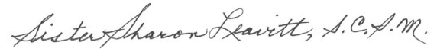
Father Bill regretted that he was to be giving a retreat in one of the Scandinavian countries right after the retreat at St. Joseph Convent. At the time of her funeral, he forwarded a beautiful tribute entitled “Thanksgiving for the Life of Sister Viola”. (His tribute is included as an addendum to this biographical sketch.)
September 15, 2023

THANKSGIVING FOR THE LIFE OF SR. VIOLA LAUSIER, S.C.I.M.
by Fr. Bill Clark, S.J.

Dear Lord, I want to thank you for the life of Sr. Viola and add my voice to the hundreds of people who are saddened by her leaving us, but also rejoicing in everything you gave her, and in the way she faithfully used those gifts for such a long time.
I thank you, Lord, that you allowed her to be part of my life for more than 25 years. When we met, Viola was already beyond the age when many people retire—but you let me see her in the midst of all the energy and enthusiasm she poured into her work at St. Andre's Home. You showed me her deep faith, that was the foundation of all the devotion she gave to the women and children cared for by St. Andre's. You inspired me by that fierce determination, her fighting spirit for the best of causes, the fruit of all that love and devotion. You let me learn from her meticulous administration of the resources that came to her, that people of faith need also to be great stewards of your gifts.
As time went on, Lord, you showed me just how very deep Sr. Vi's love and faith ran. I saw it in her spirituality and her prayer—so simple on the surface, but so able to produce startling and profound insights to the scriptures, and essential lessons for everyday Christian living. I saw her depth in the real practical kindness she showed toward people-in-need whom I introduced to her. And I saw it, over and over, in the way she took every health challenge, every change in her life, with such good grace and openness to your will. I thank you, Lord, that she died in just the same way you had taught her to live.
Yes, Lord, I thank you for giving Sr. Viola to us, for your life—shared through her for almost all of this past century—and for hearing her prayers for us that we know she is offering you, right now! Amen.

