BIOGRAPHICAL SKETCH

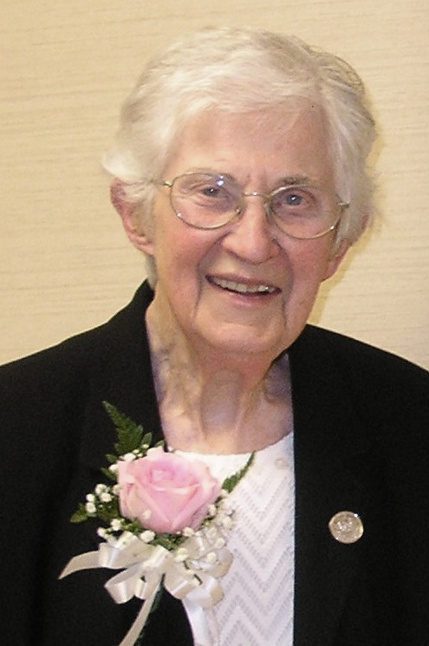

Sister Eileen Ward
(Sr. Martin Marie)
June 15, 1934 – May 9, 2022

The Lord is my shepherd,
I shall not want...
He leads me in right paths...
Even though I walk through
the darkest valley, I fear no evil,
for you are with me. (Psalm 23)

Eileen Ward was born in Corona, New York on June 15, 1934. Her parents, Martin Ward and Margaret Higgins Ward, were both born in Galway, Ireland. They entered the United States through Ellis Island in 1928. They raised their five girls in the Bronx, N.Y. Eileen was the fourth child in the family of five.

Eileen received her elementary education at Holy Cross School in the Bronx, N.Y. She began her secondary education at the Diocesan High School, Immaculate Conception and completed her third and fourth year at Cathedral High School. Upon her graduation, she worked for four years doing office work while attending Hunter College at night. From a young age, Eileen wanted to be a religious. While on a retreat when she was 21 years old, she chose three communities to contact. The Good Shepherd sisters responded to her letter. She met with the Mistress of Novices, Sr. Lillian Bonin, and decided that this was where the Good Shepherd wanted her as her personal charism matched the charism of the Community so well. The life and ministry of Marie Fitzbach Roy, her work with the poor and disenfranchised, greatly impressed Eileen and so she entered the Good Shepherd Community in 1956.

After her formation period, Eileen taught 5th grade at St. Joseph School in Biddeford. She completed her college education at Mount Saint Mary in Hooksett, New Hampshire receiving her B.A. in English. In 1964, she taught English at Van Buren Regional High School, and then taught at St. Louis High in Biddeford. She was loved and fondly remembered by her students. Later, she attended Boston College and in 1973 received her M.A. in Social Work. She always felt attracted to social work and enthusiastically entered this field and began her long career working at St. Andre Home.

Upon arriving at St. Andre Home in Bangor, Sister Eileen soon became the “Heart of the Bangor Group Home”. When the group home in Bangor opened in 1974 it was housing pregnant women exclusively. By 1978, a major change occurred when Sr. Eileen advocated for a parenting mother who had no place to go after giving birth to her baby. Administration at that time gave Sr. Eileen the green light to serve not only pregnant clients, but parenting clients and their children as well. In working at the group home, she exhibited tireless dedication, total commitment, and selfless service to the Mission of St. Andre Home until her retirement 39 years later. She loved helping women and children in need. She tried never to give up on anyone. To this day, former students and clients kept in touch with her, and she refused no one. It is often said that Sr. Eileen would give the shirt off her back if someone needed it. She was never afraid to show her humanity, and she loved people genuinely and sincerely. Sr. Eileen was a healer--a psychological and emotional healer. When asked why she had remained so long at St. Andre, she responded that "It never dawned on me to change ministry. I have found great satisfaction and meaning working at St. Andre Home". Wherever she was sent, Sr. Eileen felt that is where God wanted her to be.

Sister Eileen resided at St. Joseph Convent in Old Town from 1974 until its closure in 1984. In 1992 Sister Eileen left the Congregation but did not leave its charism and mission as is evidenced through her work with the Good Shepherd Affiliation and her ministry at St. Andre Home throughout the ensuing years.

Eileen was loved and respected by the Affiliates of Old Town who contributed the following remembrances of her at the time of her death:

Jesus said: "You are the light of the world"..."Your light must shine before others, that they may see your good deeds and glorify your heavenly Father." (John 5) Eileen was a light in the lives of the Affiliates of Old Town, Maine. She generously and unselfishly replaced Sr. Renee Caron as the moderator of the group. She accepted this call with much grace and with the heart and love of Mother Foundress.

The Affiliates of today describe Eileen as devoted, understanding, and loving. She was always well-prepared and kept everyone on track when discussions would stray from the topic. One Affiliate described Eileen as "one of us", as a friend who would listen without judgment." Eileen would even give rides to those who needed transportation to the meetings. Eileen was a spiritual mentor. As our Mother Foundress so beautifully expressed: "No, the fire kindled among us by His love will never lose its flame!" Yes, Eileen kindled that flame and let her light shine among us, and we are forever grateful!

Eileen continued this ministry to the Old Town Affiliates once she had re-entered the Congregation and was living in Biddeford until the pandemic made it impossible for her to do so.
It was after her retirement from St. Andre Home, Inc. and as age and diminishing health crept up on Eileen, that she found it necessary to leave the Bangor area and asked to return to the Good Shepherd Sisters in Biddeford who were happy to welcome her back. It was then that she requested re-admission to the Congregation.

On January 12, 2018, Rev. Joseph Manship officiated at the Final Profession of Sr. Eileen at St. Joseph Convent. Father had been stationed in Bangor during the time when Sr. Eileen was at the Bangor Group Home.

In his homily Father stated: "I recall the excitement and joy and a bit of trepidation I felt when I was invited to preach and preside on this day. I remembered a favorite scene from the movie "Man for all Seasons" about St. Thomas More. His daughter, Margaret, asks Thomas to compromise, to be less radical and generous, to save his life. Haven't you done all God could reasonably ask of a man? she asked in frustration. And Thomas More answers simply: "Finally, it's not a matter of reason, it's a matter of love".

I now realize that yes, it is a bit too much, unreasonable, but in the end, it's not a matter of reason, it's a matter of love. Today, we face a woman in love (in love with the Lord). Maybe a little forgetful, timid, still struggling, but in the end, a woman who has, like Mary and Marie Fitzbach been overwhelmed by God's generous, merciful love for her, and today, responding in the gratitude, joy and hope of Mary's Magnificat.

Dear Sr. Eileen, you are not the only one making a commitment today. The Lord of Love, our heart's deepest desire, even more deeply commits Himself to you. And my final word is borrowed from the Angel Gabriel to Mary at the Annunciation: "Do not be afraid"!

Sr. Eileen's health and strength continued to decline during the 2022 Lenten season. We were all pleasantly surprised to see her attend the Easter Vigil in her wheelchair. It must have taken a great effort on her part to be present with us. Her journey on this earth had become a great struggle as her hearing, speech and strength continued to diminish. Her work on earth was complete. It was time for her to meet her Beloved in Heaven on May 10, 2022. Two days after Mother's Day she joined her family in Heaven.

A very close friend of Sr. Eileen, Ms. Jane Vachon, delivered the Eulogy at her Mass of Christian Liturgy. Excerpts follow that summarize much of what has been said about Sr. Eileen:

”Marie Fitzbach's charism, which she left for her daughters, Servants of the Immaculate Heart of Mary, was and continues to be "Communicate Love and Goodness as God Wills". This simple but profound charism was lived wholeheartedly by Sr. Eileen Ward. Eileen's life focused on welcoming everyone and accepting them without reservation. It did not make any difference who they were.

Whether Sr. Eileen was in the classroom as a teacher or at St. Andre Home as a Social Worker, the constant was who she was. Whether it was in Community with her Sisters, or in her beloved family, she was a presence. Eileen was a loyal and caring friend. The door to her heart was always open to the students who have fond recollections of her, to the women and children and the staff at St. Andre Home who loved her dearly. Eileen was a truly authentic spiritual and prayerful person. Before she re-entered the Congregation, Eileen had a room in her house designated for prayer and meditation. She would remind the Staff at the Bangor Group Home of the Anniversary of the Foundation of the Congregation each year and helped to make Marie Fitzbach known and loved.

Eileen communicated unconditional love! She could be relied upon to help you out. She would ask “what do you need?” And she would make every effort to meet that need. Because of this, coupled with her deep spirituality and a deep and profound knowing that God is in everyone, Eileen lived a life of contemplation in action.

As a dear friend and colleague of hers stated: "Eileen walked the walk". Her actions followed her words, and her words, her actions. She was a very generous person. She was generous with her time, her money, her possessions. Sr. Eileen was a strong advocate for persons who seemed to have little power in their lives. Anyone would want her on their side.

There were times when Sr. Eileen was a bit over-trusting. She would often pick up hitchhikers and when we heard about this, we would warn her of the dangers of picking up strangers. Eileen's response was always, "Hon, you never know whether that person is the Lord". ...

A song sung by Frank Sinatra comes to mind about some aspect of her life, and the song is titled: "I Did It My Way." Those of you who lived, worked and socialized with Sr. Eileen could provide examples of this, I am sure. She will be sorely missed and each one of us knows deep down what not having her in our lives means.

It is unfortunate that these past two year of pandemic have prevented those who cared and loved her were unable to visit her and bid her farewell in person. Our faith tells us that we are all connected to each other in spirit. May Sr. Eileen feel our love today as she has felt the love and kindness of the S.C.I.M. Community in these last years of her life. She returned home with her Sisters where her heart and calling have always been as a Servant of the Immaculate Heart of Mary all the while Communicating Love and Goodness as God Wills! Trahe Nos, Virgo Immaculata! May dear Sister Eileen rest in peace."

Sister Eileen is survived by two sisters, Mary Lajoie of Las Vegas, Nevada and Hannah Clark of Pearl River, New York. Due to Covid restrictions neither was able to attend her Mass of Christian Burial held at St. Joseph Convent, Biddeford on May 13, 2022. Rev. Vincent Mallone was the celebrant and homilist. The burial took place in St. Joseph Cemetery, Biddeford, Maine.

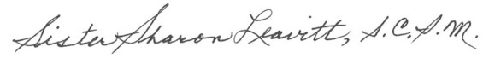

Sister Sharon Leavitt, S.C.I.M.
June 28, 2022
10th anniversary of Marie Fitzbach being declared Venerable by the Church

