BIOGRAPHICAL SKETCH

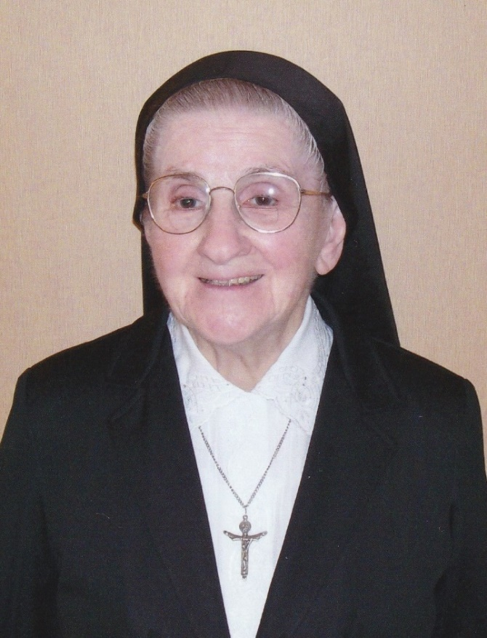

Sister Theresa Labrecque
(Sr. St. Robert de Milan)

October 6, 1923 – April 11, 2022

1802nd death
"The Lord is my shepherd. I shall not want...
He guides me in right paths,
I fear no evil; for you are at my side
With your rod and your staff that give me courage."
(Psalm 23)
As the sun set on Palm Sunday, April 10, 2022, Sister Theresa Labrecque began her journey to celebrate her first Easter in Heaven. On April 11, 2022, Sister peacefully met her Beloved Savior. Her ninety-eight-year journey was complete. Sister left us her autobiography. Excerpts from her own script follow:
“My parents were Eugene Labrecque and Ludivine Roy. Both were born in Buckland, Bellechasse County, Canada. They immigrated to the United States before the First World War and lived in Manchester, N.H. where they married in 1920. Robert was born on November 25, 1921. He became a Marist Priest. As my dad found work in the Lawrence mills, the family moved to Lawrence, MA before I was born on October 6, 1923. I was baptized the same day by Fr. Pierre Forestier, S.M. I went to St. Joseph Grammar School and High School. Being the oldest girl, in a family of eleven, I helped a lot at home both in doing housework and in taking care of the 9 younger children. Thank God my mother interceded for me when it was time to go to high school for my dad did not believe in high school for girls; none of the relatives had gone to high school. As early as I can remember, I wanted to be a nun. During my senior year when I asked my dad to enter the convent, he said, "Why don't you enter the Sisters of the Presentation of Mary?" I answered, "I know my aunts (both mom and dad had two sisters in that community, and we would visit them each summer) but I do not know their community. Don't you think if God permitted that I go to school for 13 years with the Sisters of the Good Shepherd, perhaps He wants me there?" I won my point!
I entered the Good Shepherd Novitiate in Biddeford, Maine on August 25, 1942. My First Profession was on August 15, 1944. I spent one year at the Mother House in Quebec where I made my Scholasticate. I was then named to our Van Buren Convent and taught in the local schools of the area.
Now I would like to speak about the members of my family. Let us start with the girls: Cecile and Jeannette became Good Shepherd Sisters; Lillian and Pauline both entered the Oblates of Bethanie Community. As for the boys: Robert became a Marist Priest and Roger also became a Marist Missionary Priest. The four other boys, Louis, Albert, Raymond and Richard married.
In January 1954, I was named for our Basutoland Missions. Of course, I had given my name to the Superior General after my perpetual vows in 1949. It took five years before they got back to me but every day, in my prayer I said to God, "If you want me to go to Africa, You'll take care of things." And He did! You must know that we were volunteers for Africa, but still needed to ask our parents' permission to go. My mom had answered, "Now that we have given you to God, you may go where you wish." Also in 1954, we were going to Lesotho for life. But it so happened that at the General Chapter of the Community that was held after that date, it was decided that the missionaries could visit home after 10 years. Then it was decided that as long as we had a good reason, the community allowed us a home visit.”
Sister Claire Lambert, who also served in Lesotho, gave the eulogy at Sr. Theresa’s funeral. Sr. Claire summarized Sr. Theresa’s 40 years among the Basotho by presenting tributes prepared by several Sisters of Good Shepherd Province in Lesotho. The Sisters shared that although Sr. Theresa left Lesotho 28 years ago, she continues to be remembered with love and gratitude as their Mosotho-American Sister. The Sisters of Lesotho lovingly described Sister Theresa in the following manner:
'M'e Theresa--was a prayerful, loving person who respected our people. She was always humble and sincere, but also honest and outspoken in telling us the facts whether we got upset or not. Because she was considered to be one of us, the Basotho felt she must be given a name that described her character. 'Mapotlako was her Sesotho name...which means, "A woman who moves fast, and who acts quickly". She knew the name that had been given her, and with a smile, accepted it with her simplicity and love.
Sr. Theresa was a dynamic Math and Science teacher who demonstrated love and care for her students, always willing to do everything possible to foster their career and professional development, and ever ready to help those who were not clever.
She showed great happiness in community, at school, and in all her interactions. Having served in different missions, she enabled many Basotho to become responsible citizens.
In her service as local superior, she was profound and devoted to give support and care to all under her servant leadership. She had no special sister; all were equal and the same to her.
Piety and tidiness marked her lifestyle. She would not go to school without first sweeping the dining hall. She was a true model of religious life by her actions and deeds.
In her ministry as Pro-Provincial Bursar, she showed passion and dedication. She was humble and hard working. Many Sisters learned how to keep financial records through her supervision. She left us a legacy that we are bound to transmit to younger generations.
We so wish to take after her by being responsible, consecrated women of today and tomorrow as God wills. May the soul of this Servant of the Immaculate Heart of Mary and the souls of the departed through the mercy of God, rest in peace. AMEN.
Due to the pandemic, our Sisters of Lesotho had not visited Sr. Theresa recently, but whenever they could they spent time with her and shared in their Sesotho language which Sister had mastered and never forgotten.
Sr. Claire Lambert then noted in the eulogy that upon Sr. Theresa’s return to the U.S.A. she was happily and willingly recruited to work in the Bay View Villa office by the Director (her friend and high school classmate), Sr. Anita Therrien. In Sr. Theresa’s own words: “She taught me so well that when she was ill and not able to return, I knew what to do”. Having organizational and accounting skills, and being bilingual--able to communicate effectively with both French and English speaking guests-- made her a treasured “gift” to this Bay View ministry of hospitality.

Once Bay View Convent closed Sr. Theresa became a resident of the infirmary at St. Joseph Convent. She continued to be socially oriented and eager to volunteer her services and to participate in community events. She chose not to make use of the television in her room; she would generally be found in the Activity Room to watch television in the company of others--whether the evening news or any other scheduled programs. Hers was a faithful participation in whatever activities were scheduled. Early in the morning she claimed the chair beside the parakeet ready to welcome the first shift nursing personnel with her special greeting: "How is your own dear self?" Then she was first to arrive for the 6:30 opening of breakfast in the main dining room, and often the last to leave. A Good Shepherd sister who is fondly remembered as a Mosotho-American, Theresa lived simply, shared all that she had, and loved much. Borrowing from her more recent and frequently repeated expression: That's it! From Sr. Theresa's grateful heart to each of you, she speaks the phrase she had come to express for every small service given her: "Thank you, and God bless you!"

Mrs. Marlene Cohen, as an affiliate, spent many hours sitting with Sr. Theresa while being tutored in French. Being able to recall many memorable dates and events Sr. Theresa shared much of her family life and mission life with Marlene. Marlene shared how she loved to watch her when she was telling her life-stories. As Marlene stated: “Sr. Theresa would close her eyes and smile, reliving the past moments. Her hands would move in a soft way while she shared, giving emphasis to her words with the enthusiasm of a young girl dancing around the fields. I always admired her determination when she thought of something that should be done and her deep faith and love of God that helped her to win the battle she fought during painful times. I was fascinated with her missionary life. I smiled when she told me that she traveled on horse-back, crossing rivers accompanied by another sister and a Mosotho guide to go to another mission. Then, in 2020 the Covid epidemic prevented our weekly meetings. However, Sr. Theresa lives on in my fondest memories of my beloved friend.”
Theresa was calm and peaceful as she suffered the illness that led to her final days. On her few hours between hospital stays she greeted by name each member of the General Council who were visiting at St. Joseph Convent. Sr. Theresa very quietly and peacefully met the Lord on April 11, 2022. Her Mass of Christian Burial took place at St. Joseph Convent on April 19, Easter Tuesday. Reverend Norm Richard was the celebrant and homilist at her Mass. Father Richard, our former Chaplain at Bay View, knew Sr. Theresa very well and described her in the following quotes: She was a happy Sister Servant who served the Community very joyfully. What impressed me about her was her holiness. Quite often I mentioned to her that she was a saint. And she would answer: "In the making". As I mulled over what to say in her homily I felt I should emphasize her "Joie de vivre." Sister led a good life. I am sure that she experienced trials and disappointments in life, but in general, she was a happy, joyful person because of her faith and love of Jesus. As a woman of faith, I believe that when the door opened for her on April 11 she believed with all her heart that her Master, Jesus Christ would be on the other side along with her dear parents, her many siblings, and her dear Mother Foundress, Venerable Marie Fitzbach Roy.
Attending her Mass of Christian Burial was her brother Louis accompanied by his wife, Suzanne, and one of their daughters. Her brother, Albert, who lives in Florida was unable to attend due to health conditions. Her two living religious sisters were also unable to attend.
Sister Theresa Labrecque's spirit lives on in the memories of our entire community. She sat in the hallway in her last years to greet all who passed. She may be gone from our midst, but she is certainly not forgotten. May she rest in peace!

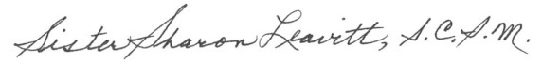
Sister Sharon Leavitt
May 19, 2022

